A

Project Report On

Online Blogging System



Presented To Department of Computer Science Ganpat University, Kherva

Group No 56

Presented By

Kaushik Patel (13084231131)

Bhikhabhai Patel (13084231091)

## Project Profile:

|  |  |
| --- | --- |
| Project Defination | Online Blogging System |
| Objective | The main objective of the system is to connect people socially with each other and share idea among them. User can Share the Photo, video. They are Chat with the friend and also send mail & message. User view the advertisement. |
| Platform | Web Application |
| Internal Guide | Mr. Jaimit R. Patel |
| Front End | Asp.net(2010) with C# Framework 4.0 |
| Back End | Ms Sql Server 2008 |
| Other Tools | MS Office 2007,Photoshop, Ajax tooltip. |
| Time Duration | 90 Days. |

**Existing System:**

* Twitter and Facebook does not capable send Email.
* Twitter and Facebook does not provide facility of send SMS on mobile
* Twitter does not provide facility of share event and count the member for coming your .
* Twitter does not provide online chatting with friends.

## Need For New System:

* + In new system we can see notification.
  + We can manage status,photo,video or album.
  + New system capable to send Email and SMS on mobile facility.
  + We can manage event and count to the member of coming in this event.
  + Online chatting with their friends.
  + We can view the advertised.

## Functional Specification

Admin

* + Login

In this module Admin can register in the site and login into the site.

* + Manage User

In this module Admin can manage for all User.

* + Manage News

In this module Admin can manage News.

* + Send Mail & message

In this module Admin can send the mail & message..

* + Manage Notification

In this module Admin can manage notification.

* + Manage Event

In this module Admin can manage Event.

* + Manage Photo/video

In this module Admin can manage Photo/Video album.

* + Advertisement

In this module Admin can manage the multiple Advertisement.

User

* + - Registration

In this module user can Registration in the site.

* + - Update Status

In the update Status module user can update status.

* + - Profile
    - Events
    - Albums
    - Chat
    - Find Friend

In the profile module user can set own profile

In this module user can create events and inform the friends for events.

In the album module user can create multiple albums and share this albums to the friends.

In the chat module user can online chat with friends.

In this module user can find friend and socially communicate with each other.

* + - Photo/Videos
    - Message
    - E-mail

In this module user can upload multiple videos.

In this module user can send message and chat with others In this module user can send mail to multiple own friends

* + - Advertisement

In this module user can view the multiple Advertisement.

## Minimum Hardware Requirement:

Server Side:

|  |  |
| --- | --- |
| Processor | 1.0 GHz |
| RAM | 1 GB |
| Hard Disk | 40 GB |

Client Side:

|  |  |
| --- | --- |
| Processor | 800 MHz |
| RAM | 512 MB |
| Hard Disk | 20 GB |

## Minimum Software Requirement:

Server Side:

|  |  |
| --- | --- |
| OS | Window Server 2003 |
| Web Server | IIS 6.0 |
| Front End | .NET Framework 4.0 |
| Back End | Microsoft SQL Server 2008 |

Client Side:

|  |  |
| --- | --- |
| OS | Window XP or any compatible OS |
| Browser | Internet explorer 7.0 or any compatible Browser |

### System Flow Chart

Start

Is No

Registered

?

Registration

Login

No Is

Valid

?

Yes

Yes

Yes

Is No

Admin

?

Manage Video And Photo Manage Notification Manage Friend Request Manage News & Event

Manage User Profile Send Mail & Message Manage Advertisement

Yes Change Profile

Manage Video & Photo Send Friend request View Notification

Send SMS And Email Chat

View Event & News View Advertisement Manage friends



Logout

Stop

## Gantt chart

|  |  |  |  |  |  |  |  |
| --- | --- | --- | --- | --- | --- | --- | --- |
| Task | Time Duration (In Days) | | | | | | Total Days |
|  | 15 | 30 | 45 | 60 | 75 | 90 |  |
| Requirement Gathering & Analysis |  | | | | | | 15 |
| Designing |  | | | | | | 15 |
| Coding |  | | | | | | 35 |
| Testing |  | | | | | | 15 |
| Deployment & Implementation |  | | | | | |  |
| 10 | | | | | | |
|  | | | | | |  |
| Total |  | | | | | | 90 |

send

send

Request from

_userid

M

Message from

_userid

M

M

REQUEST

Message description

MESSAGE/EMAIL

Request to

_userid

Message_to

_userid

M

Send

Manage

Username

1

1 1

manage

M M

EVENT

Manage

1 1 1

Admin_id

USER

1

Event_Id Friend_Id

Eventdate

ADMIN

1 1

1

1 M M

Password

View Advertisement Manage

Password

1 Create& Manage

M M

ALBUM/PHOTO

create & Manage

Album_Id

Photo_Id

Upload

Album_Desc

M M

VIDEO

Manage



Video_Id

Video_Desc

Uploaded Date_Id

# Uml Diagram

## Use case diagram for Admin

**Use case diagram for User**

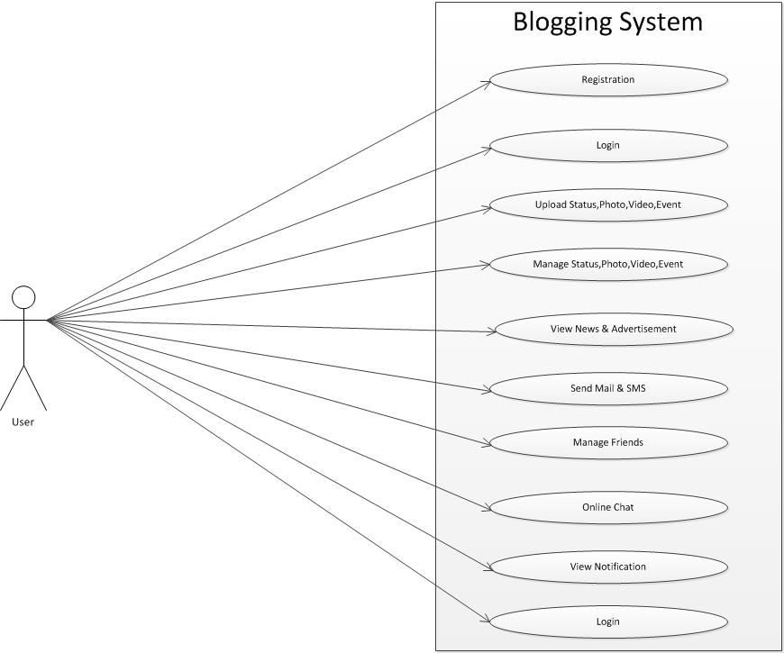

## Activity Diagram for Admin

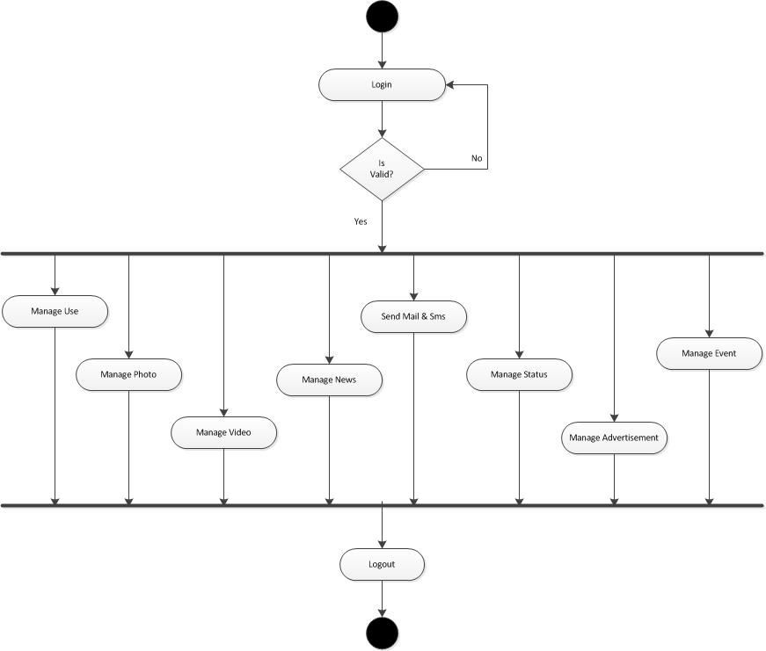

**Activity Diagram for User**

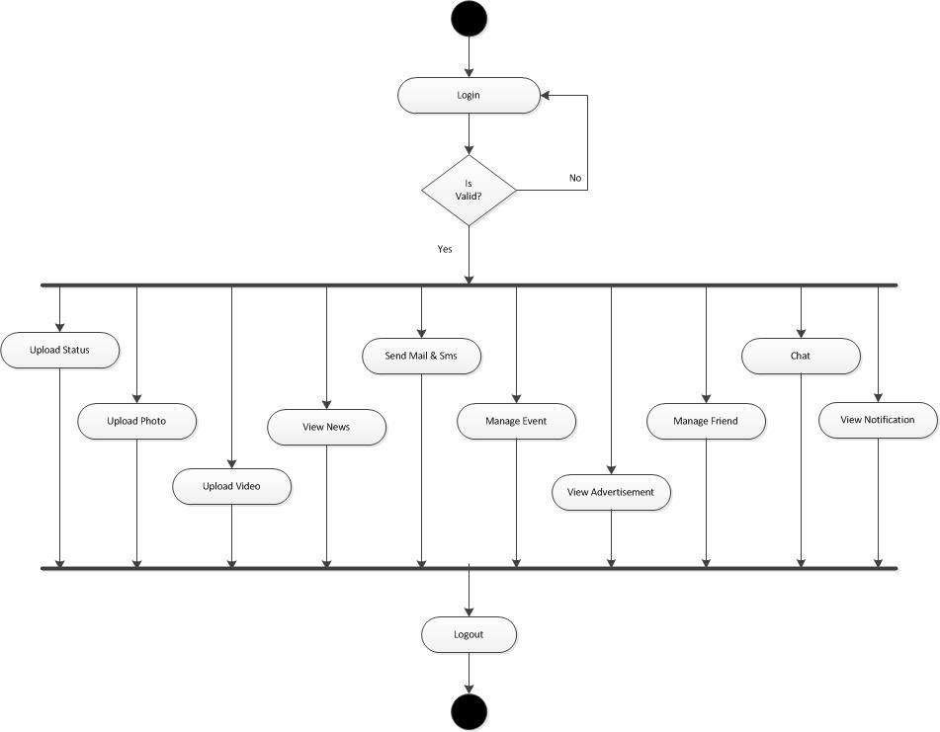

## class diagram

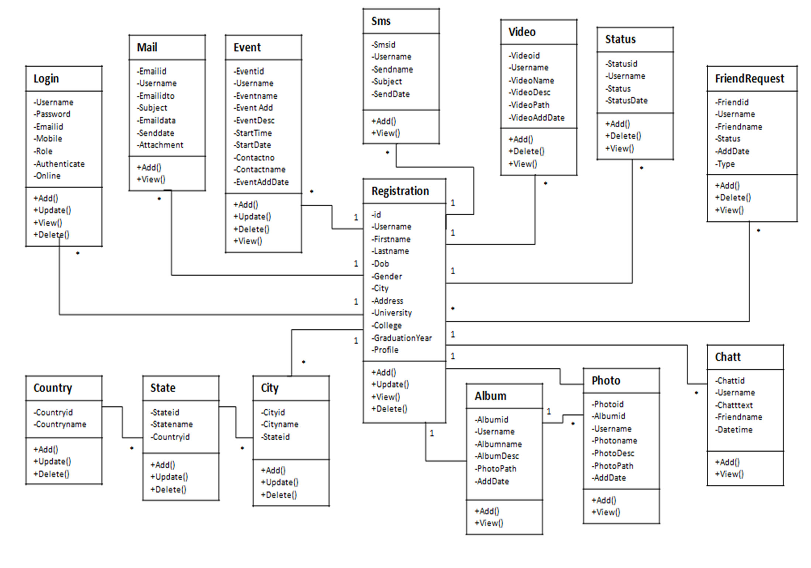

**Sequence diagram for Admin**

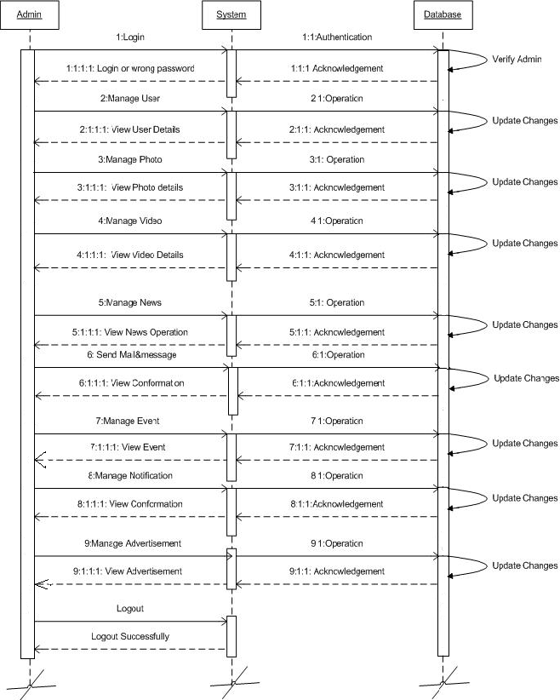

## Sequence diagram for user

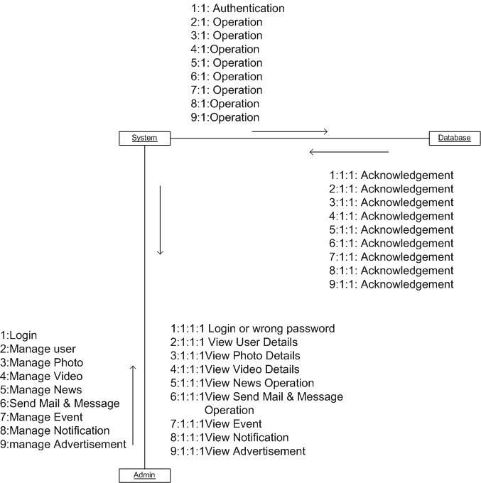**Collabration diagram for Admin**

## Collabration diagram for User

**Data Dictionary**

Table name: Login_Mst Primary Key: Username

Description: This Table is used to store Login details.

|  |  |  |  |
| --- | --- | --- | --- |
| **Fields** | **Data Type** | **Key** | **Description** |
| Username | VARCHAR(30) | Primary Key | It’s Store user unique id |
| Password | VARCHAR(15) | Not Null | It’s Store user password |
| E-Mail | VARCHAR(30) | Not Null | It’s Store user e-mail address |
| Mobile | NUMERIC(10) | Not Null | It’s Store user mobile |
| Role | VARCHAR(1) | Not Null | It’s Store to role such as User so role is U and Admin then role is A. |
| Status | VARCHAR(1) | Not Null | It’s Store to status such as User Is Online Then O otherwise F |
| Authenticate | VARCHAR(3) | Not Null | It’s Store to User Access permission ON Or OFF |

Table name: Registration_mst Primary Key: Id

Foreign Key: Username

Description: This Table is used to user details set in own profile.`

|  |  |  |  |
| --- | --- | --- | --- |
| **Fields** | **Data Type** | **key** | **Description** |
| Id | INT | Primary Key | It‘s Store profile unique id |
| Username | VARCHAR(30) | Foreign Key | Reference of User Login_Mst Table |
| First name | VARCHAR(30) | Not Null | It‘s Store user first name |
| Last name | VARCHAR(30) | Not Null | It’s Store user last name |
| Dob | DATETIME | Not Null | It’s Store user birth date |
| City | VARCHAR(20) | Not Null | Reference of City_Mst Table |
| Address | VARCHAR(200) | Not Null | It’s Store to user address |

|  |  |  |  |
| --- | --- | --- | --- |
| Address | VARCHAR(50) | Not Null | It‘s store user Address |
| Gender | VARCHAR(06) | Not Null | It’s Store user Gender |
| University | VARCHAR(100) | Allow Null | It’s Store user University |
| College | VARCHAR(100) | Allow Null | It’s Store user College |
| Graduation_Year | NUMERIC(4) | Allow Null | It’s Store user Graduation |
| Profile_Image | VARCHAR(100) | Allow Null | It’s Store user Image path |

Table name: Country_Mst Primary Key: Countryid

Description: This Table is used to store country details.

|  |  |  |  |
| --- | --- | --- | --- |
| **Fields** | **Data Type** | **key** | **Description** |
| Countryid | INT | Primary Key | It’s Store country unique Id |
| Countryname | VARCHAR(50) | Not Null | It’s Store country name |

Table name: State_Mst Primary Key: Stateid Foreign Key: Countryid

Description: This Table is used to store state details.

|  |  |  |  |
| --- | --- | --- | --- |
| **Fields** | **Data Type** | **key** | **Description** |
| Stateid | INT | Primary Key | It’s Store state Unique Id |
| Statename | VARCHAR(20) | Not Null | It’s Store state name |
| Countryid | INT | Foreign Key | Reference of country_Mst table |

Table name: City_Mst Primary Key: Cityid Foreign Key: State_Id

Description: This Table is used to store city details.

|  |  |  |  |
| --- | --- | --- | --- |
| **Fields** | **Data Type** | **key** | **Description** |
| Cityid | INT | Primary Key | It’s Store city unique Id |
| Stateid | INT | Foreign Key | Reference Of State_Mst Table |
| Cityname | VARCHAR(20) | Not Null | It’s Store city name |

Table name: News_Mst Primary Key: Newsid

Description: This Table is used to store News details

|  |  |  |  |
| --- | --- | --- | --- |
| **Fields** | **Data Type** | **key** | **Description** |
| Newsid | INT | Primary Key | It’s Store News Unique id |
| Newssubject | VARCHAR(20) | Not Null | It’s Store news subject |
| Newsimage | VARCHAR(30) | Allow Null | It’s Store news image path |
| Newsdescription | VARCHAR(100) | Not Null | It’s Store news description |
| Newsdate | DATETIME | Not Null | It’s Store news uploaded date |

Table name: Advertisement Primary Key: Advertisement_id

Description: This table is used to store Advertisement details

|  |  |  |  |
| --- | --- | --- | --- |
| Fields | Data Type | Key | Description |
| AdvertisementId | INT | Primary Key | It’s Store Advertisement Unique Id |
| Linkforadv | VARCHAR(200) | Not Null | It’s Store Link. |
| Image | VARCHAR(50) | Not Null | It’s Store the image. |

Table name: Notification_Mst Primary Key: Notificationid

Description: This Table is used to store Notification

|  |  |  |  |
| --- | --- | --- | --- |
| **Fields** | **Data Type** | **key** | **Description** |
| Notificationid | INT | Primary Key | It’s Store notification unique id. |
| Username | VARCHARE(30) | Not Null | It’s Store to User Name |
| Notification | INT | Not Null | It’s Store defined event In attend person |
| Eventide | INT | Foreign Key | It’s Store to event id |
| Notificationdate | DATETIME | Not Null | It’s store the notification date |

Table name: Event_Mst Primary Key: Eventid Foreign Key: Username

Description: This Table is used to user set in own events.

|  |  |  |  |
| --- | --- | --- | --- |
| **Fields** | **Data Type** | **key** | **Description** |
| Eventid | INT | Primary key | It’s Store Event unique id |
| Username | VARCHAR(30) | Foreign Key | Reference of user Login_Mst table |
| Eventname | VARCHAR(15) | Not Null | It’s Store event name |
| Eventdescription | TEXT | Null | It’s Store event Description |
| Eventaddress | VARCHAR(50) | Not Null | It’s Store event address |
| Startdate | VARCHAR(50) | Not Null | It’s Store event start date |
| Starttime | VRCHAR(50) | Not Null | It’s Store event end date |
| Eventdate | DATETIME | Not Null | It’s Store event created date |
| Contactname | VARCHAR(15) | Null | It’s Store event contact name |
| Contactnumber | NUMERIC(10) | Null | It’s Store event contact number |

Table name: Album_Mst Primary Key: Albumid Foreign Key: Username

Description: This Table is used to user can create in personal albums.

|  |  |  |  |
| --- | --- | --- | --- |
| **Fields** | **Data Type** | **key** | **Description** |
| Albumid | INT | Primary key | It’s Store album unique id |
| Username | VARCHAR(30) | Foreign Key | Reference of user Login_Mst table |
| Albumname | VARCHAR(30) | Not Null | It’s Store album name |
| Albumdesc | TEXT | Null | It’s Store album Description |
| Albumimage | VARCHAR(50) | Not Null | It ‘s Store album image file name |
| Albumdate | DATETIME | Not Null | It’s Store album created date |

Table name: Video_Mst Primary Key: Videoid Foreign Key: Username

Description: This Table is used to store Video details

|  |  |  |  |
| --- | --- | --- | --- |
| **Fields** | **Data Type** | **key** | **Description** |
| Videoid | INT | Primary key | It’s Store video unique id |
| Username | VARCHAR(30) | Foreign Key | Reference of user Login_Mst table |
| Videoname | VARCHAR(30) | Null | It’s Store video name |
| Videodesciption | TEXT | Null | It’s Store video Description |
| Videopath | VARCHARE(200) | Not Null | It’s Store to video path |
| Videodate | DATETIME | Not Null | It ‘s Store video posted date |

Table name: Photo_Mst Primary Key: Photoid

Foreign Key: Albumid,username

Description: This Table is used to user can post multiple images.

|  |  |  |  |
| --- | --- | --- | --- |
| **Fields** | **Data Type** | **Key** | **Description** |
| Photoid | INT | Primary key | It’s Store photo unique id |
| Albumid | INT | Foreign Key | Reference of user Album_Mst table |
| Username | VARCHAR(30) | Foreign Key | Reference of user Login_Mst table |
| PhotoName | VARCHAR(30) | NULL | It’s store the photo name. |
| Image | VARCHAR(30) | Not Null | It’s Store image path |
| Photodesciption | TEXT | Null | It’s Store photo Description |
| Photodate | DATETIME | Not Null | It’s Store photo posted date. |

Table name: Status_Mst Primary Key: statusid Foreign Key: Username

Description: This Table is used to store status details.

|  |  |  |  |
| --- | --- | --- | --- |
| **Fields** | **Data Type** | **key** | **Description** |
| Statusid | INT | Primary key | It’s Store status unique id |
| Username | VARCHAR(30) | Foreign Key | Reference of user Login_Mst table |
| Status | TEXT | Not Null | It’s Store status Description |
| Statusdate | DATETIME | Not Null | It’s Store status created date |

Table name: Frequest_Mst Primary Key:Id

Foreign Key: Username

Description: This Table is used to store user friends.

|  |  |  |  |
| --- | --- | --- | --- |
| **Fields** | **Data Type** | **key** | **Description** |
| Id | VARCHAR(10) | Primary Key | It’s Store unique id |
| Username | VARCHAR(30) | Foreign Key | Reference of user Login_Mst table |
| Friendname | VARCHARE(10) | Not Null | It’s store friendsname |
| Status | INT | Not Nul | It’s Store friend status |
| Friendadddate | DATETIME | Not Null | It’s Store friend Joined dated |

Table name: Sms _Mst Primary Key: Smsid Foreign Key: Username

Description: This Table is used to send sms to the user.

|  |  |  |  |
| --- | --- | --- | --- |
| **Fields** | **Data Type** | **Key** | **Description** |
| Smsid | INT | Primary Key | It’s Store sms unique id |
| Username | VARCHAR(30) | Foreign Key | Reference of user Login_Mst table |
| Sendname | VARCHAR(30) | Not Null | It’s Store sender person id. |
| Text | TEXT | Null | It’s Store store text |
| Senddate | DATETIME | Not Null | It’s store the date on which date send the sms. |

Table name: Email_Mst Primary Key: Emailid Foreign Key: Username

Description: This Table is used to store email details.

|  |  |  |  |
| --- | --- | --- | --- |
| **Fields** | **Data Type** | **Key** | **Description** |
| Email_ID | INT | Primary Key | It’s Store Email unique id |
| Username | VARCHAR(30) | Foreign Key | Reference of user Login_Mst table |
| Sendto | VARCHAR(30) | Not Null | It’s Store email sent address |
| Emailsubject | VARCHAR(30) | Null | It’s Store email subject |
| Emaildesc | TEXT | Null | It’s Store email text |
| Senddate | DATETIME | Not Null | It’s store the date on which date send the mail. |
| Attachment | VARCHAR(30) | Null | It’s will store the attachment file in the mail. |





Admin Login Page

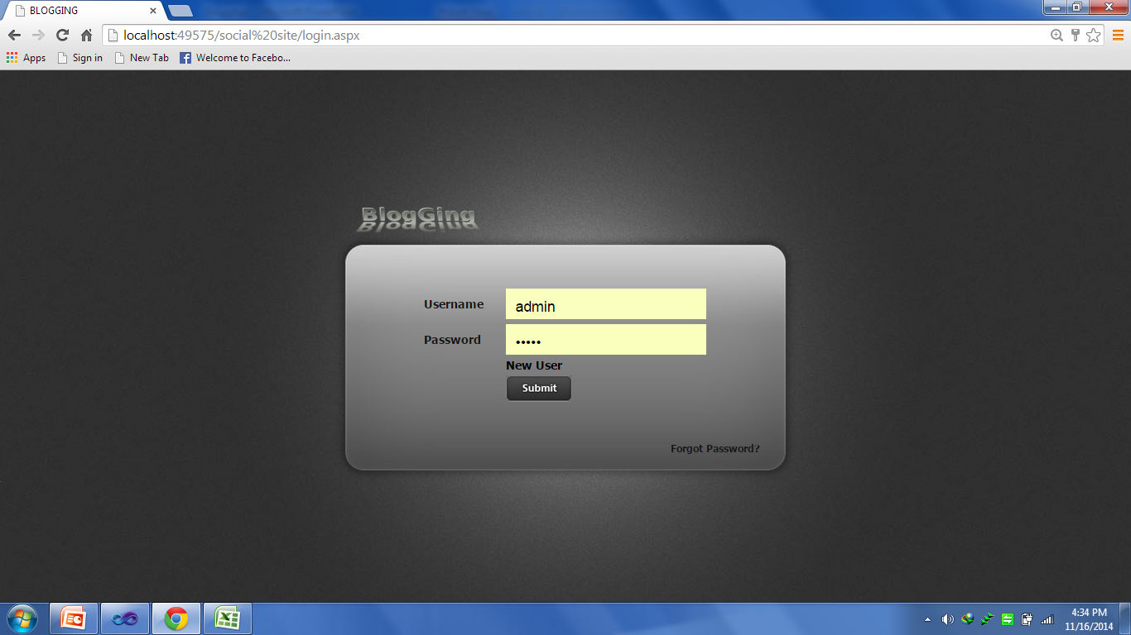

In this page admin will be login with valid user name and password.

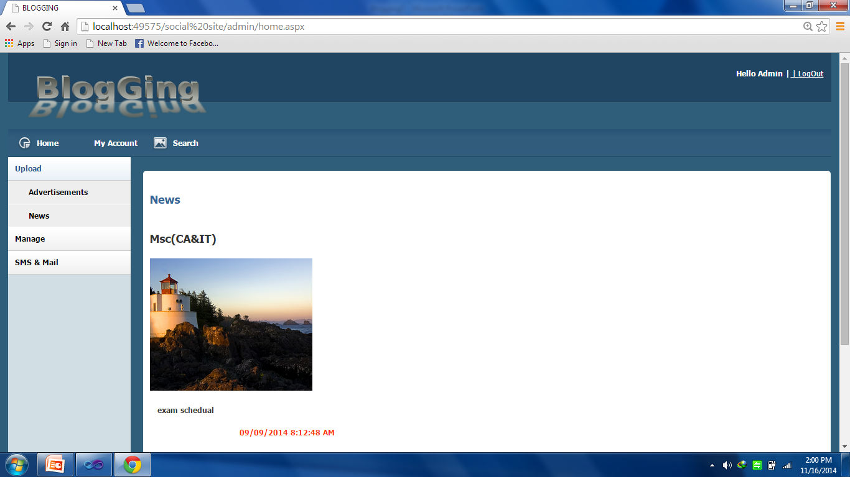Admin Home Page

This is admin home page after admin login he will be redirect to this page.

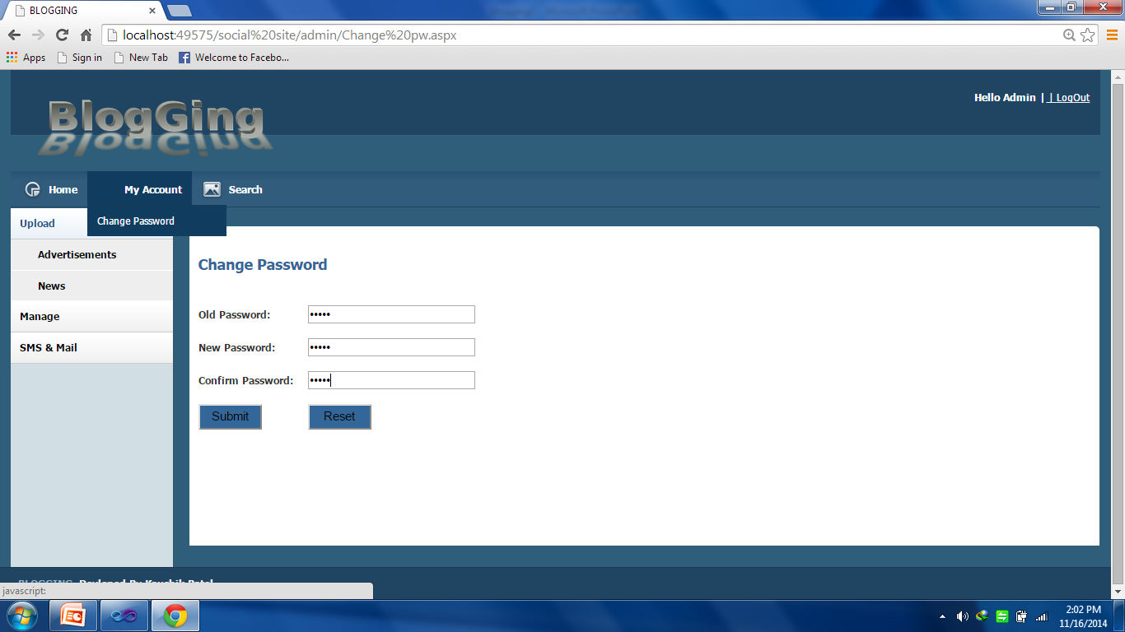Admin Change Password Page

This is change password page for admin. Admin can change the old password.

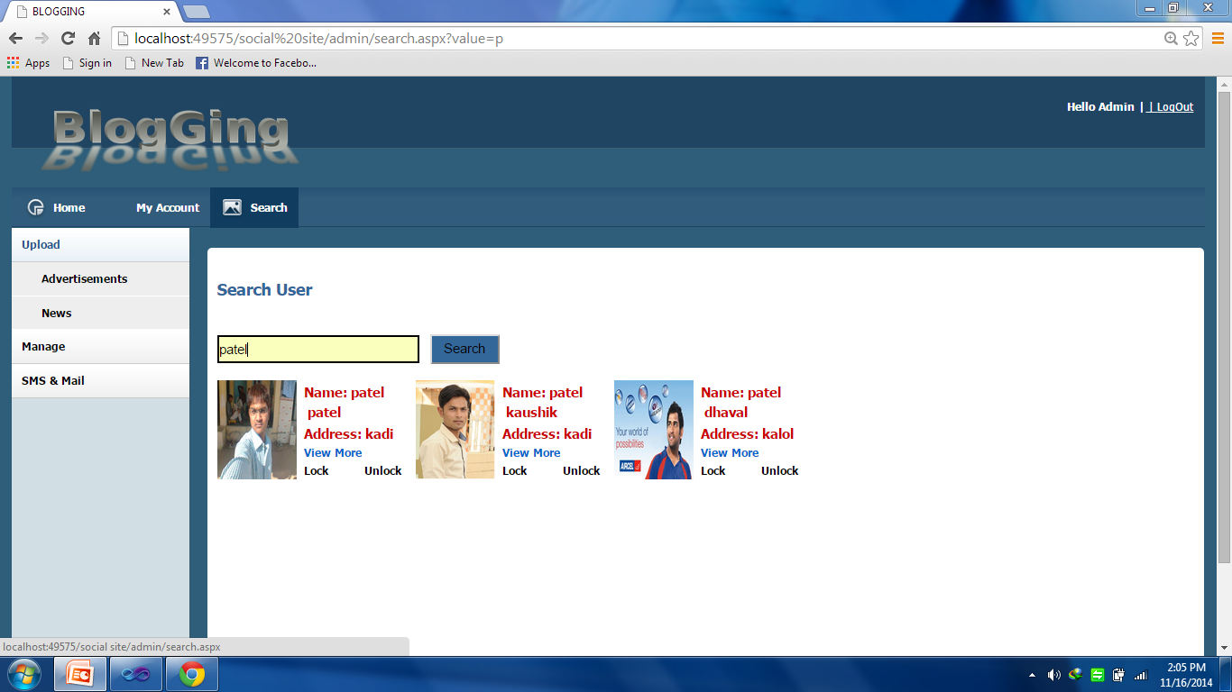Admin Search All User

In this page admin can search the all user and view or active or deactive the all user.

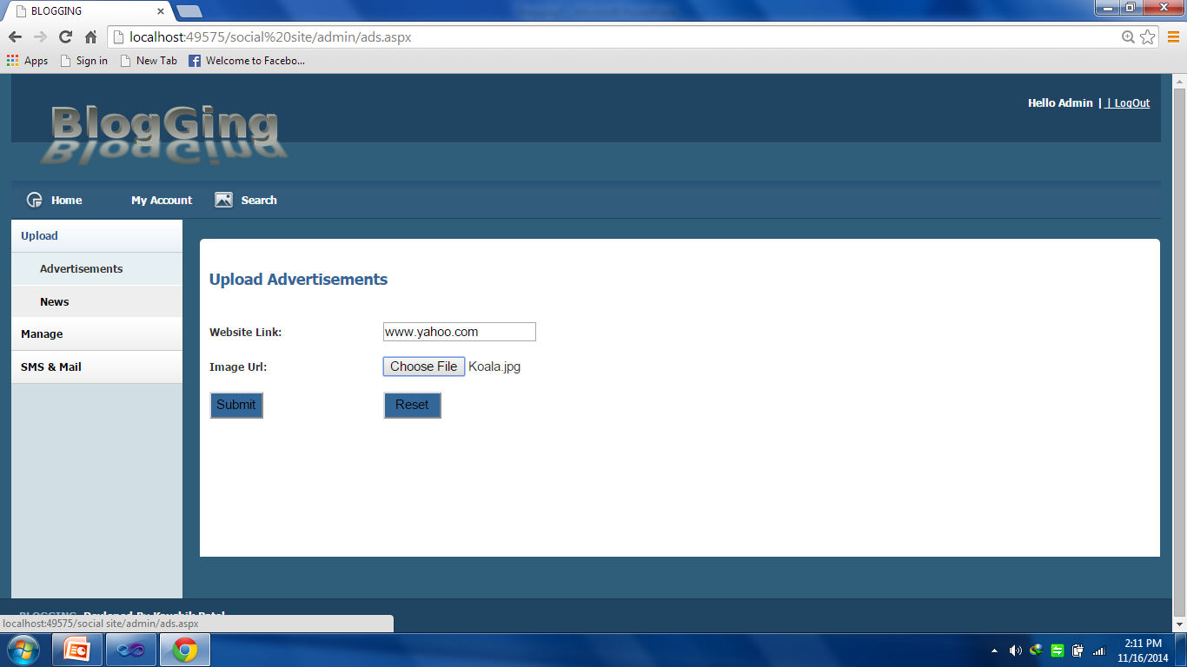Admin Upload Advertisement Page

In this page admin can upload the advertise with its image and Redirect link it will display on the user’s home page.

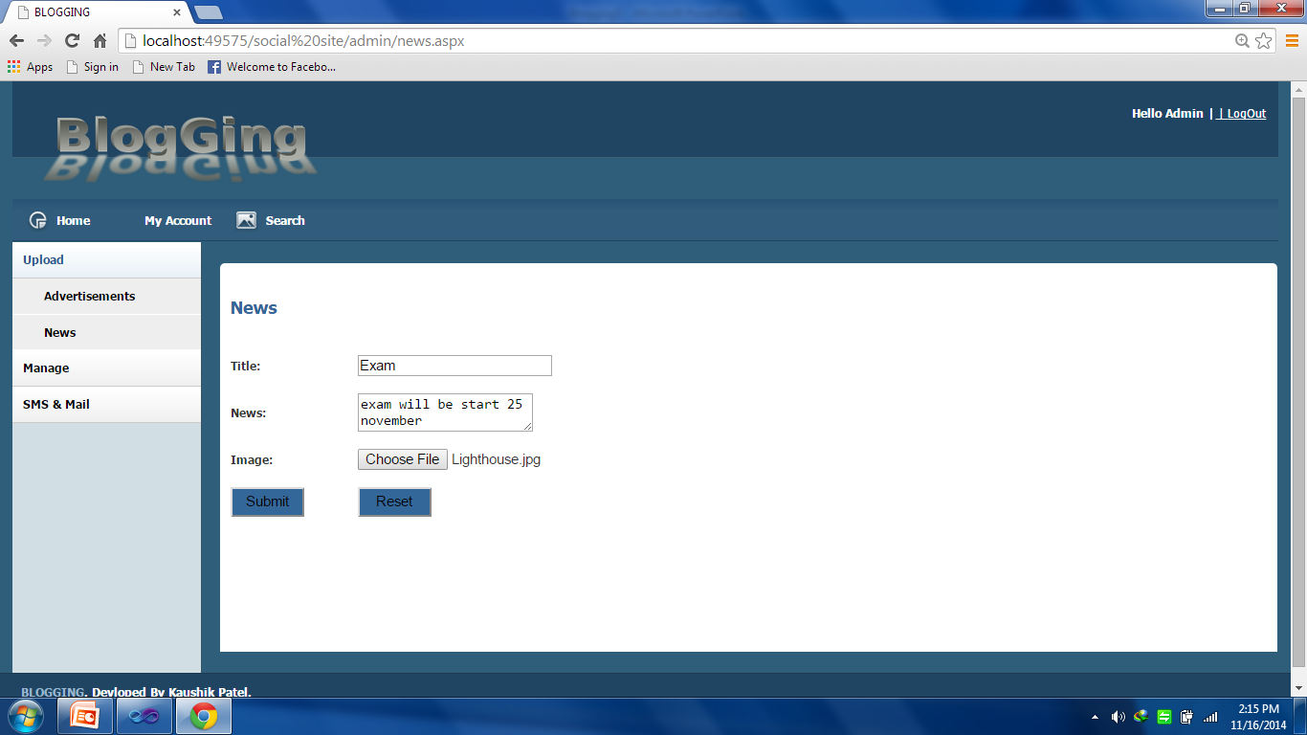Admin Upload News Page

In this page admin can upload the news with its image and it will display on the user’s home page.

Admin Manage News Page

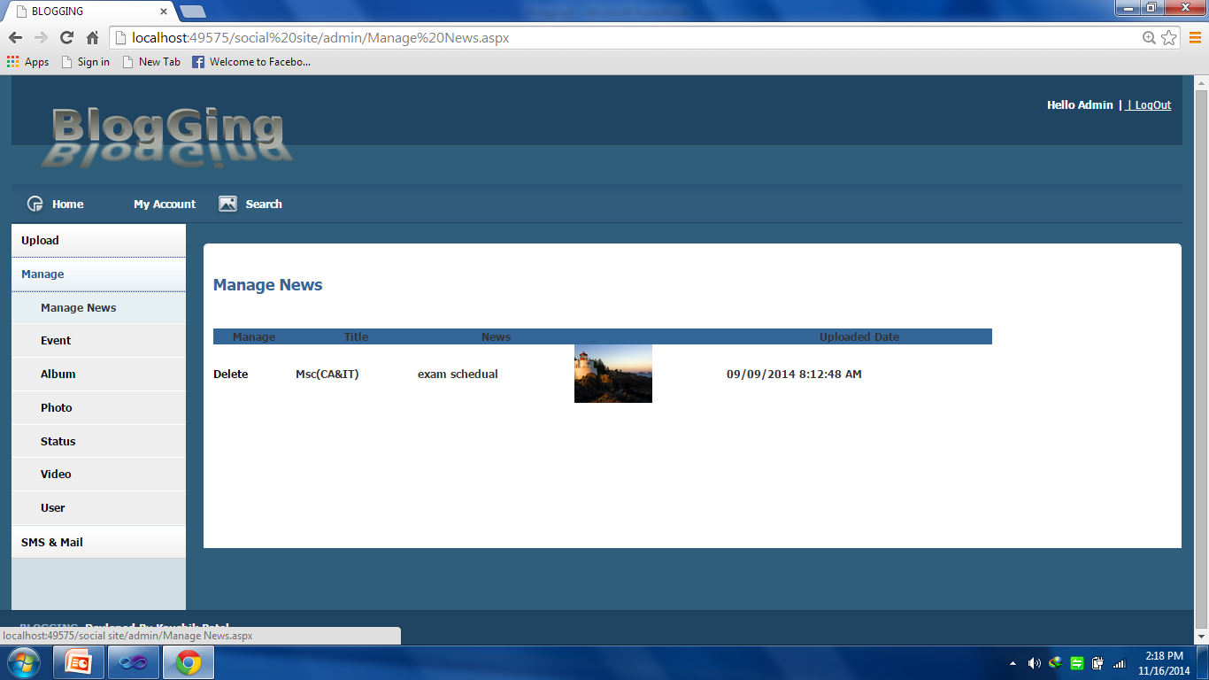

In this page admin can Manage the News with its image and it will Remove on the user’s home page.

Admin Manage Event Page

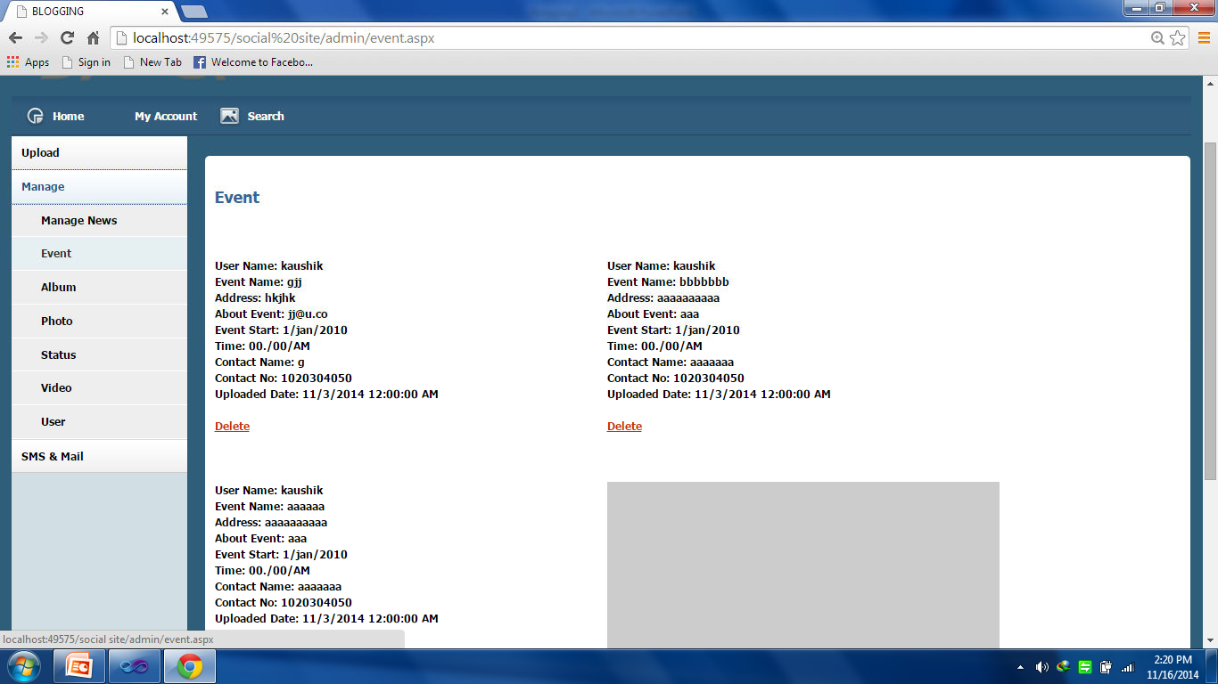

In this page admin can manage the Event like view or delete the user Event.

Admin Manage Album From All User

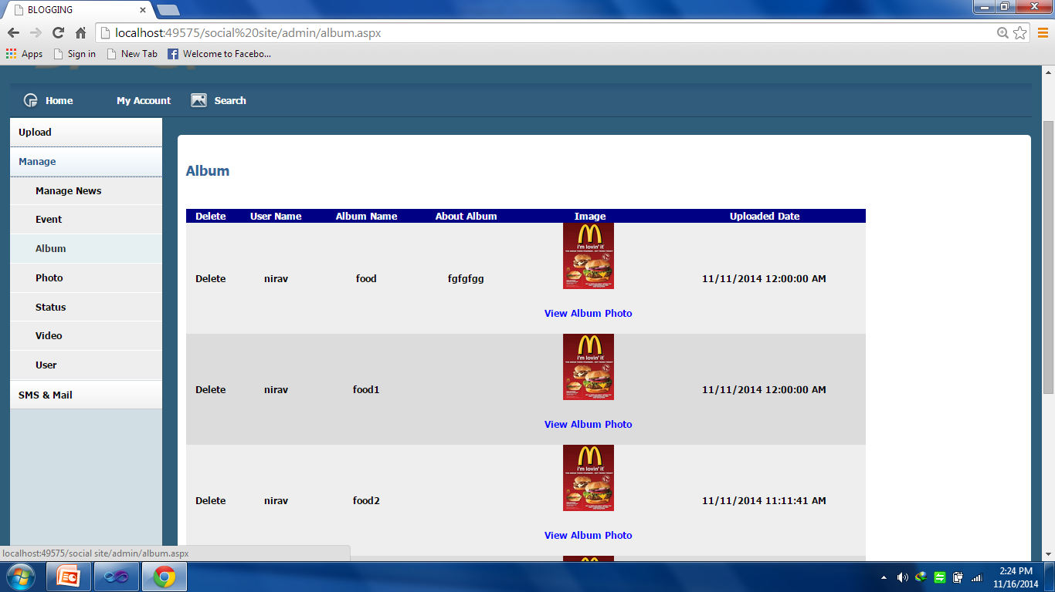

In this page admin can manage the all Album which is uploaded by user.

Admin Manage Photo From All User

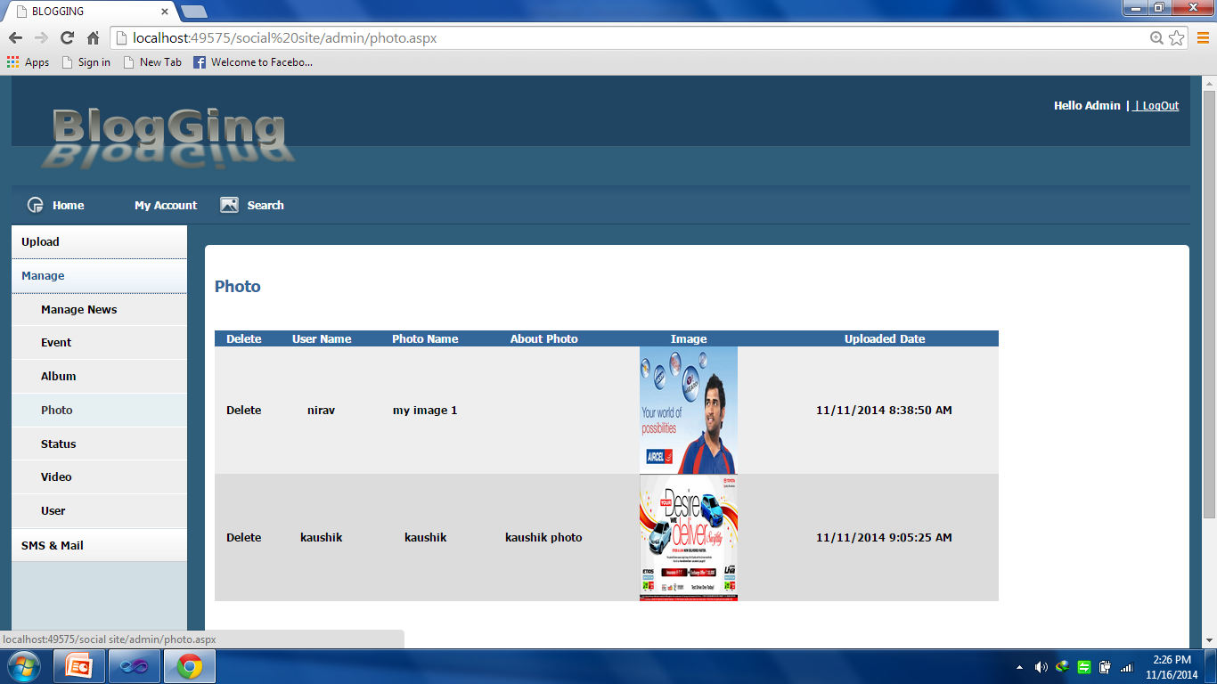

In this page admin can manage the all photo which is uploaded by user.

Admin Manage Status From All User

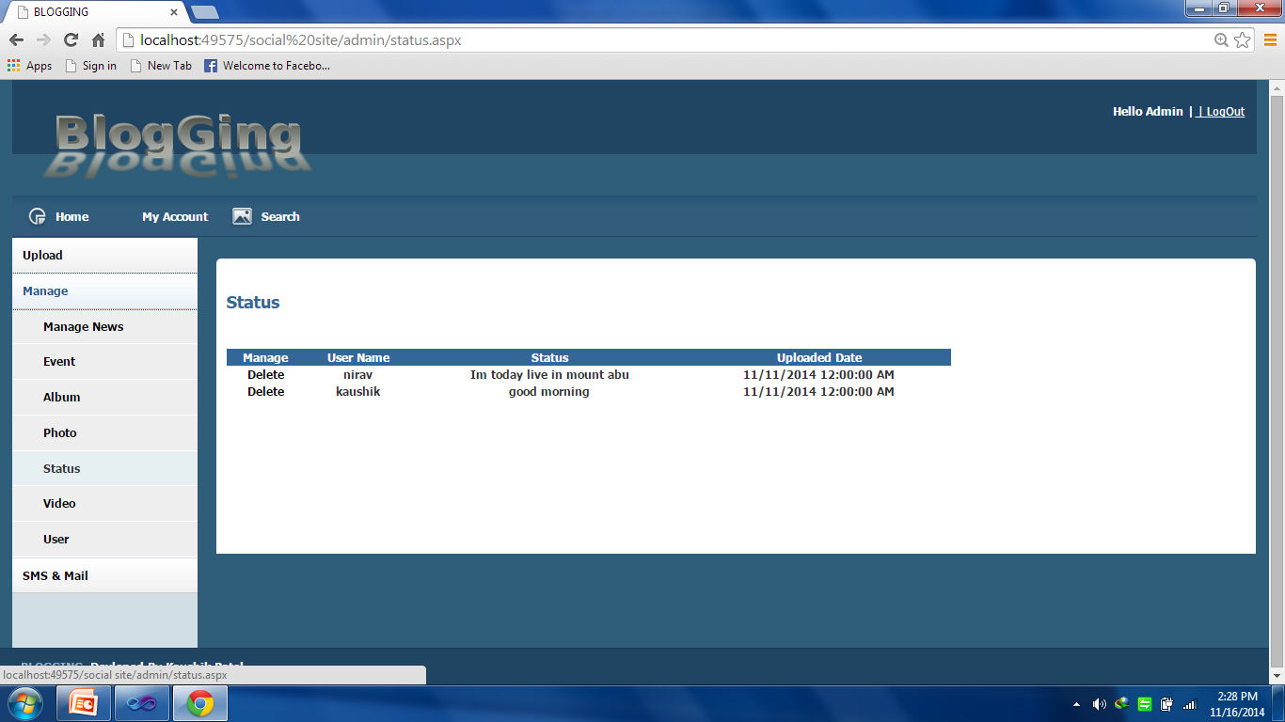

In this page admin can manage the user status like view or delete.

Admin Manage Video From All User

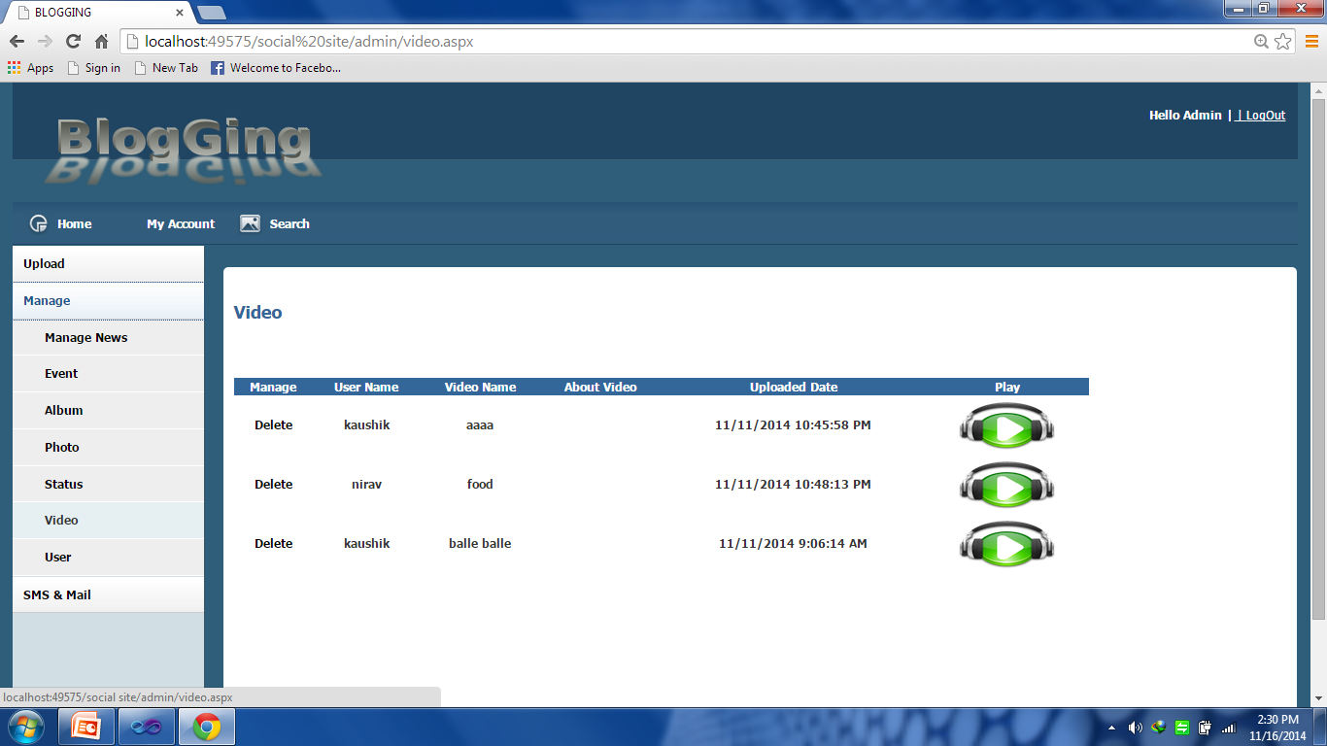

In this page admin can manage the all user uploaded videos.

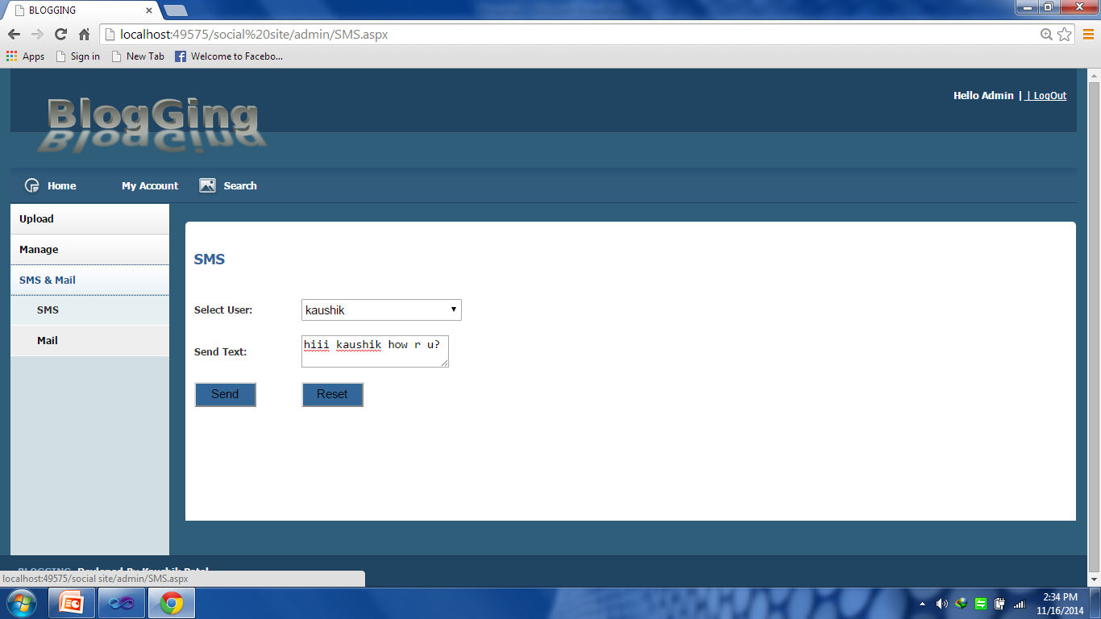Admin Send SMS Page

This page is used for sending the sms to all user or particular user.

Admin Send Mail Page

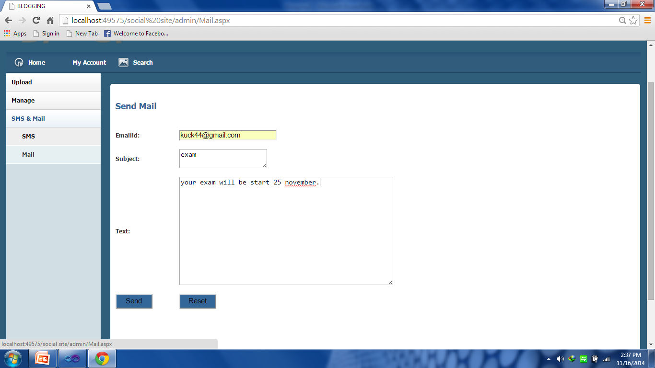

This page is used for sending the E-mail to all user or particular user.

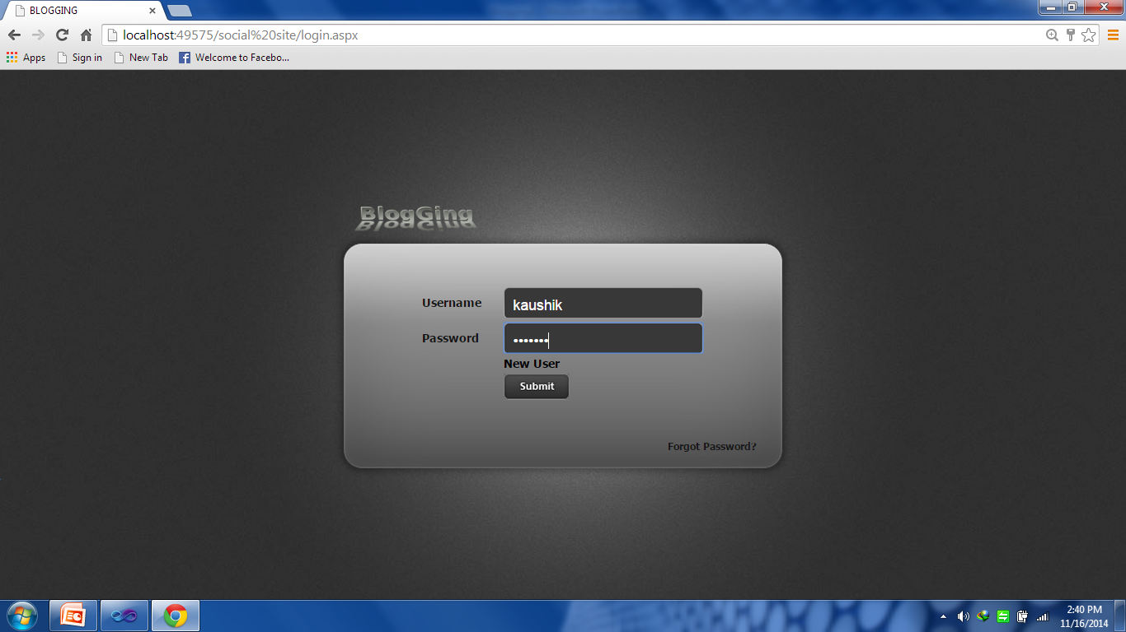

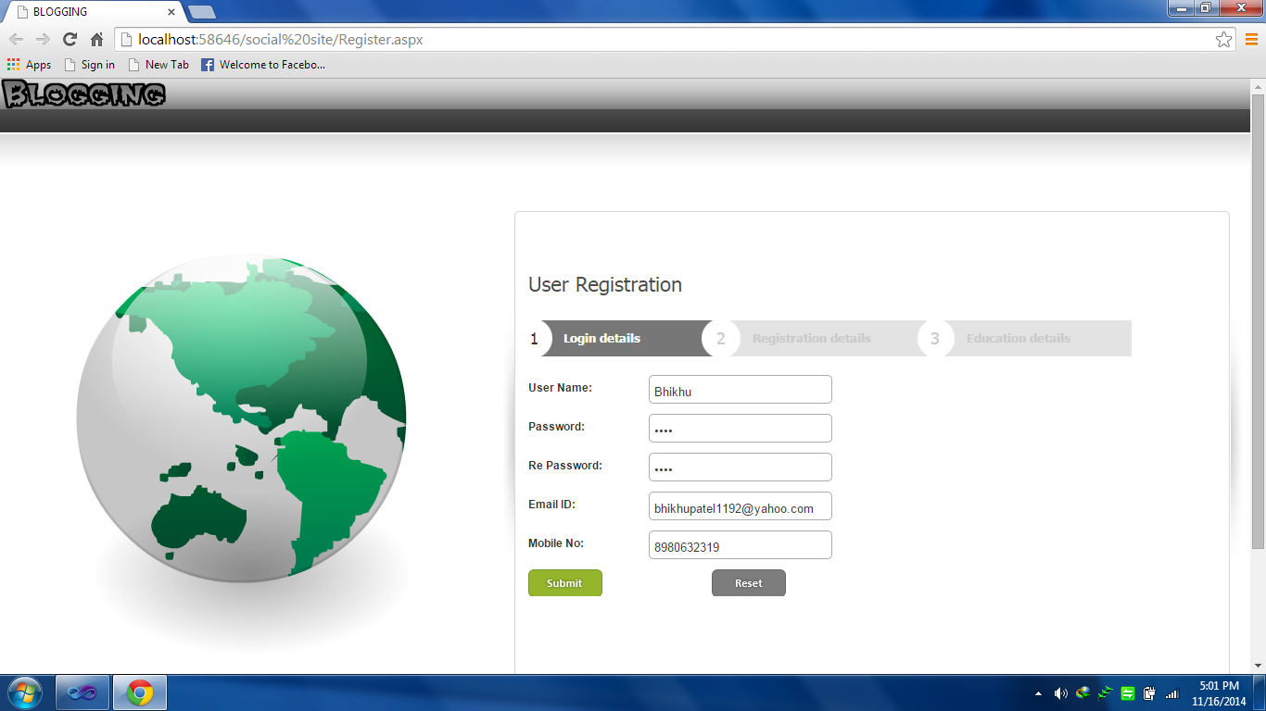User Registration in Login detail Form

This is user registration page where new user can register the information.

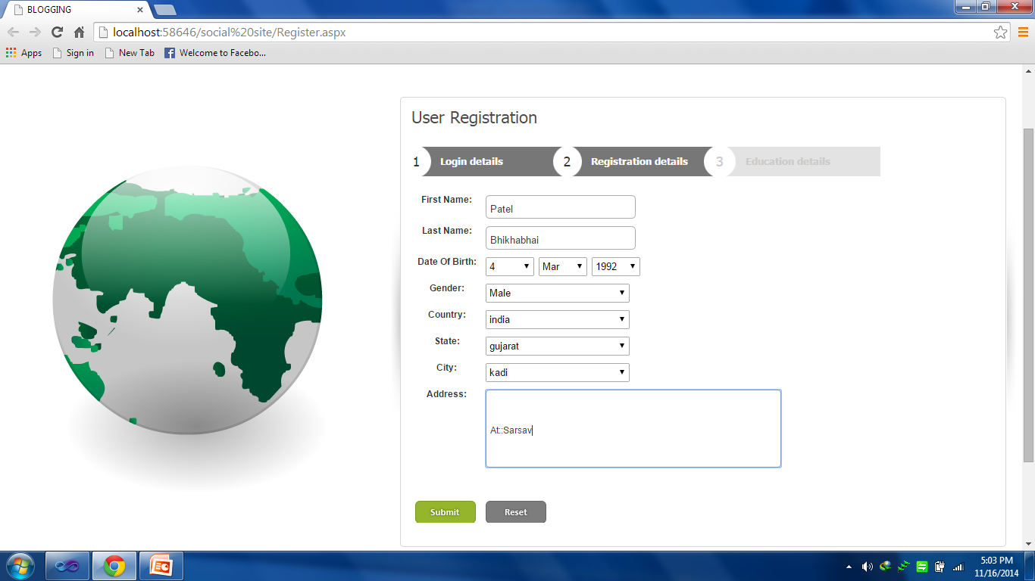User Registration in Personal detail Form

This is user registration page where new user can fillip in personal detail on Registration time

User Registration in Educational detail Form

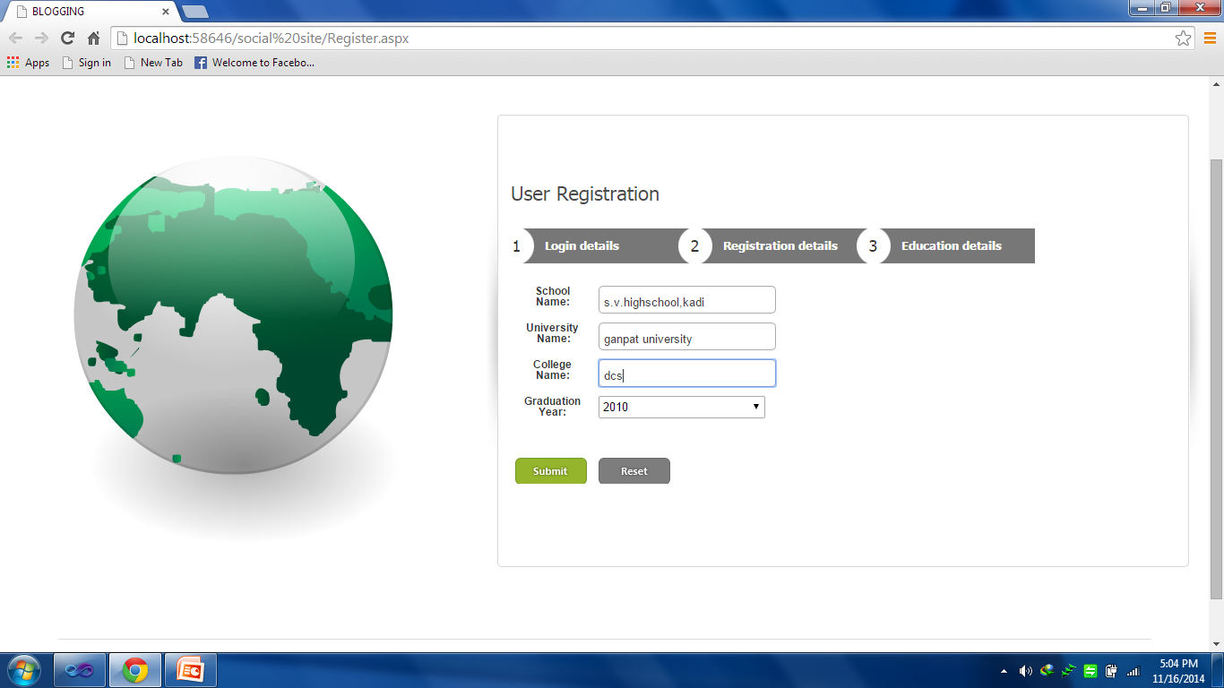

This is user registration page where new user can fillip in Educational detail on Registration time

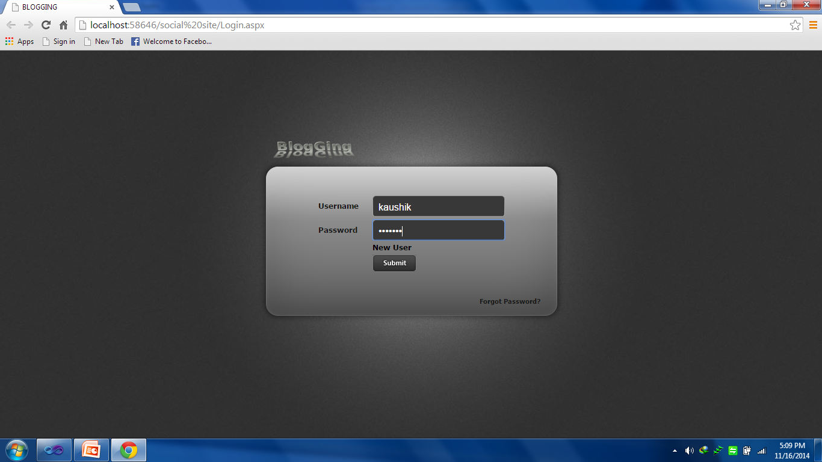User Login Page

In this page User will be login with valid user name and password.

User Forgot Password

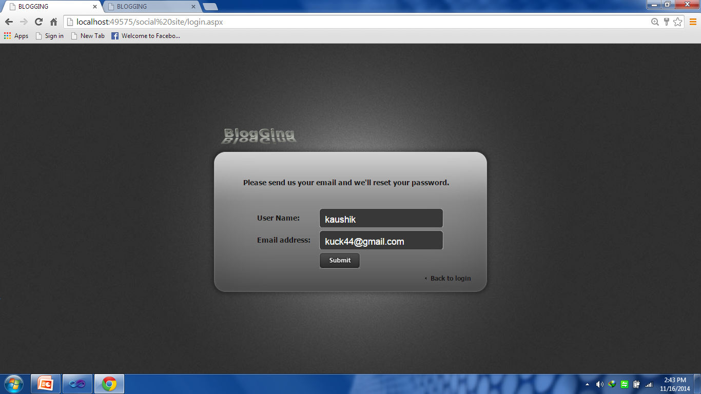

This is forgot password page where if user forgot the password then user can recover the password.

User Home page

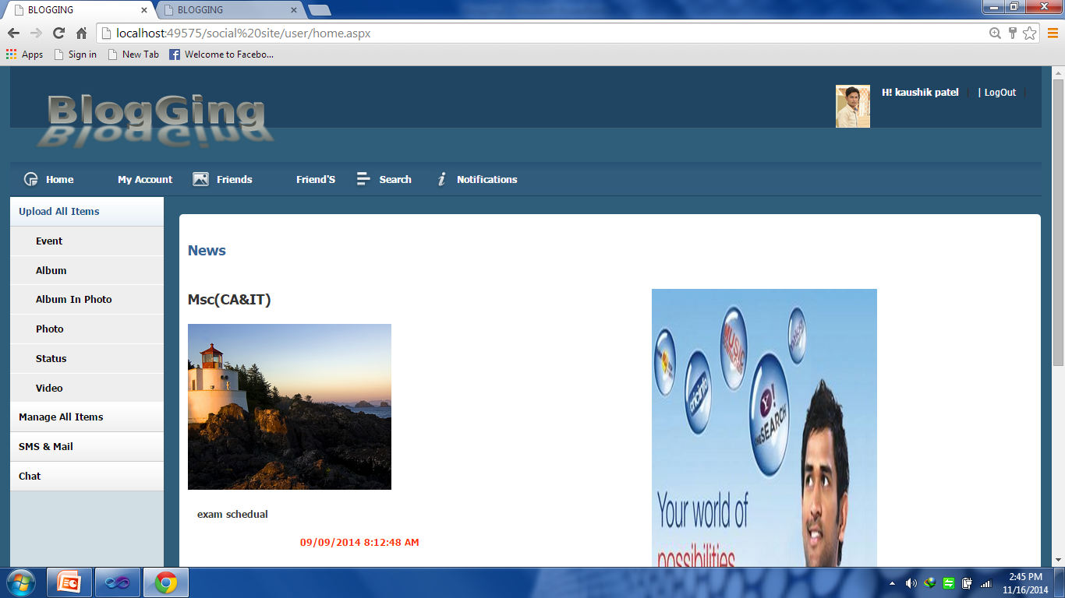

This is user home page.

User Change the profile Page

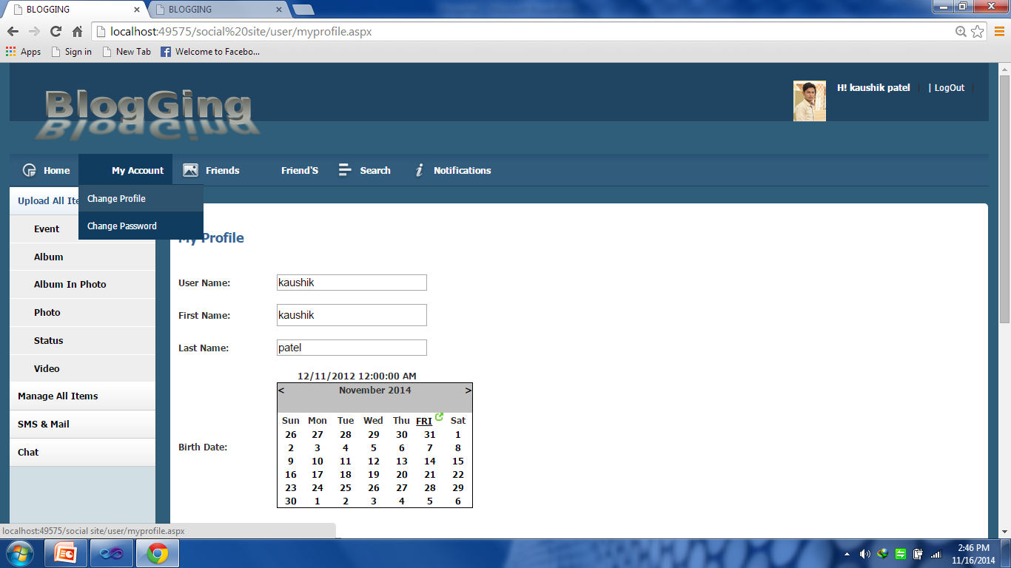

In this page user can change the profile.

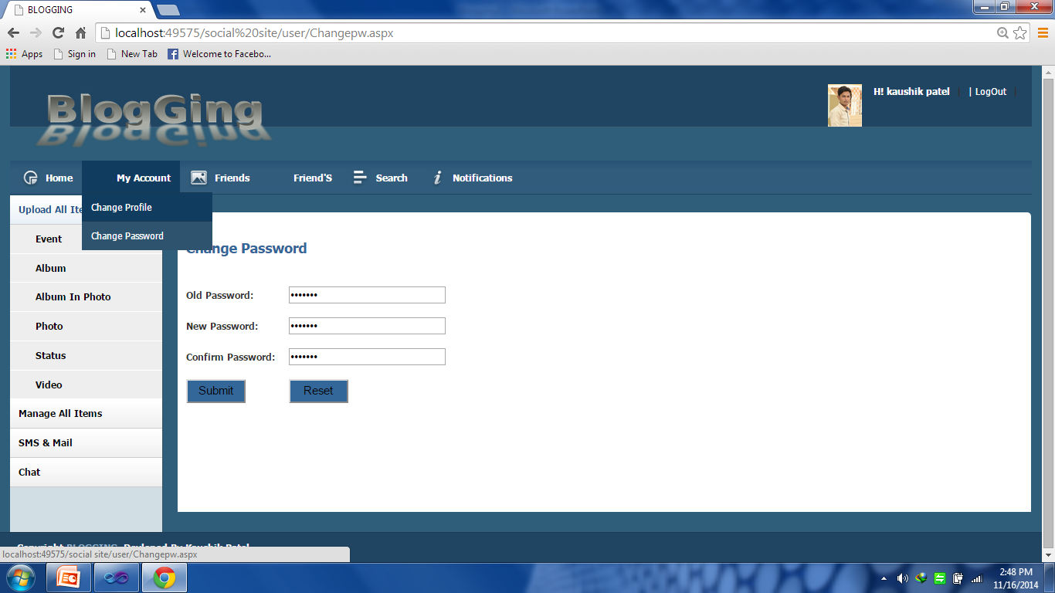User Change Password Page

In this page user can remove the old password and write the new password.

User Friend Request Page

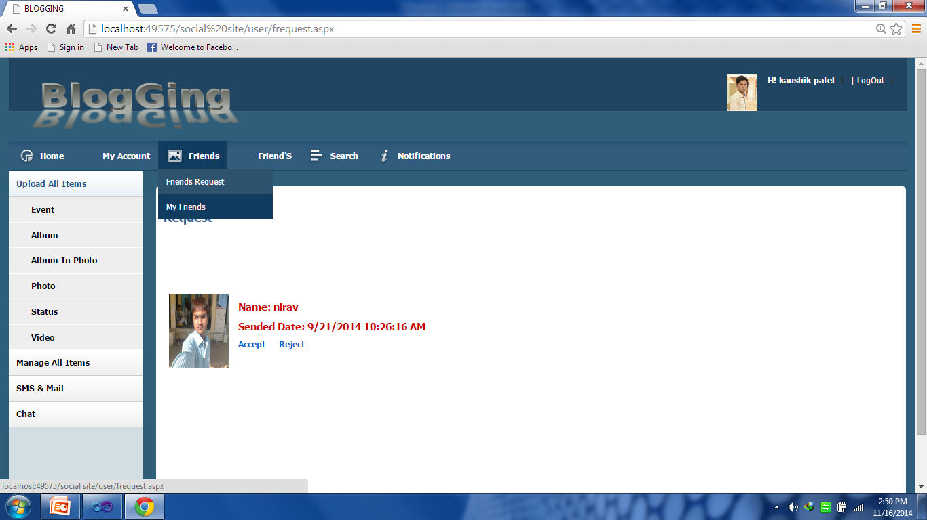

In this user can accept or reject the friend request.

User View Friend Page

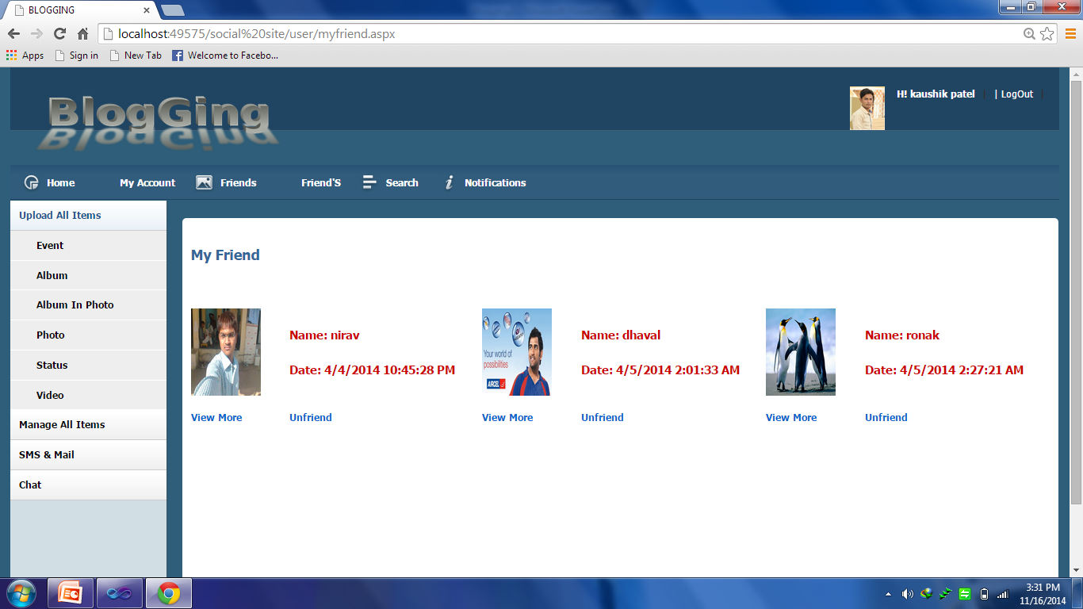

In this page user can view the friend and remove the friend in this page.

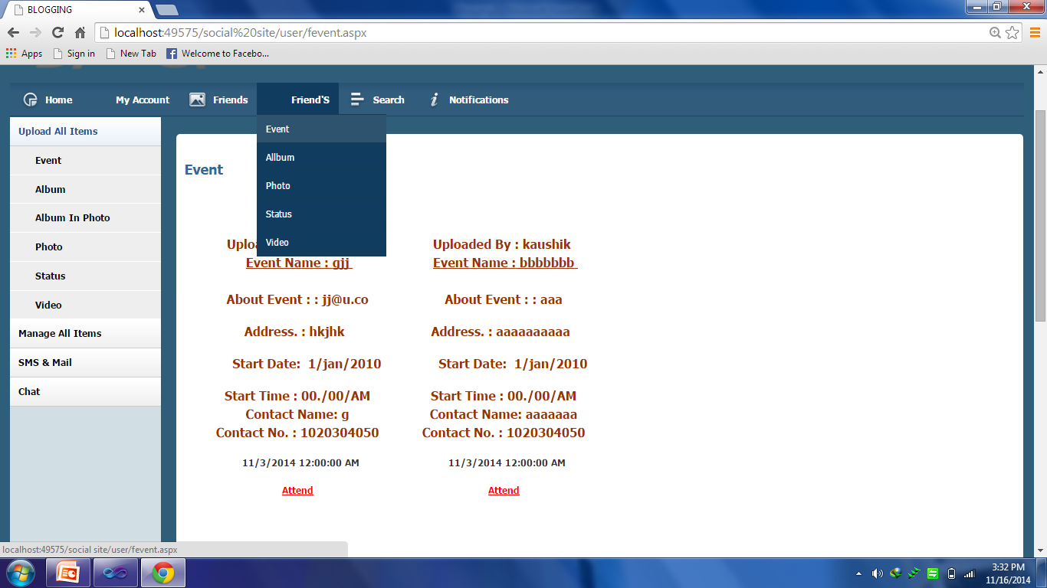User View Friend Event Page

In this page user can view the friends Event.

User View Friend Album Page

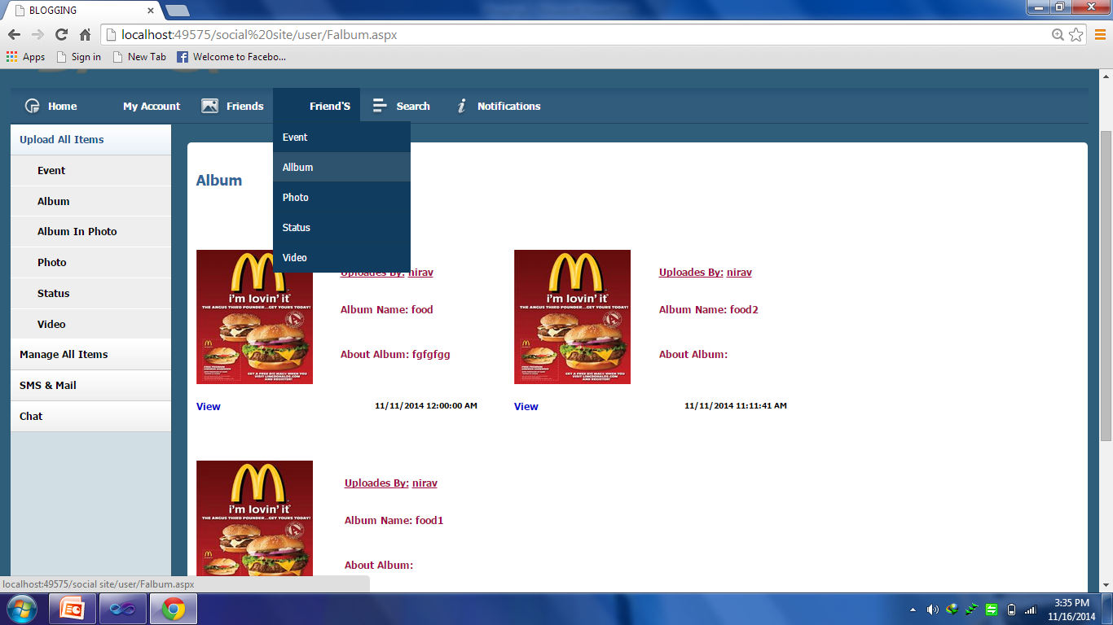

In this page user can view the friends photo album.

User View Friend Album Image Page

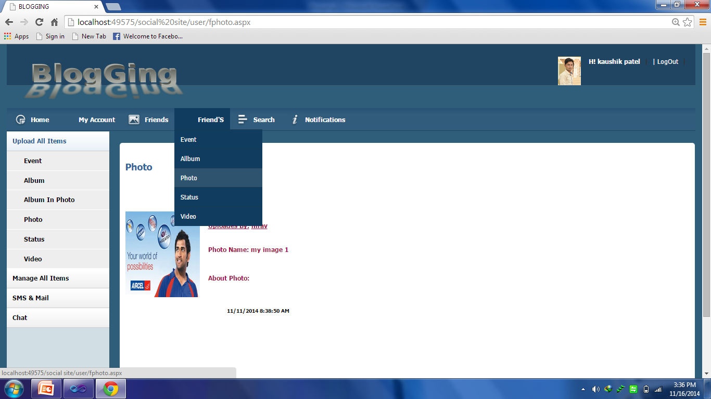

In this page user can view the single album image into the album.

User View Status Page

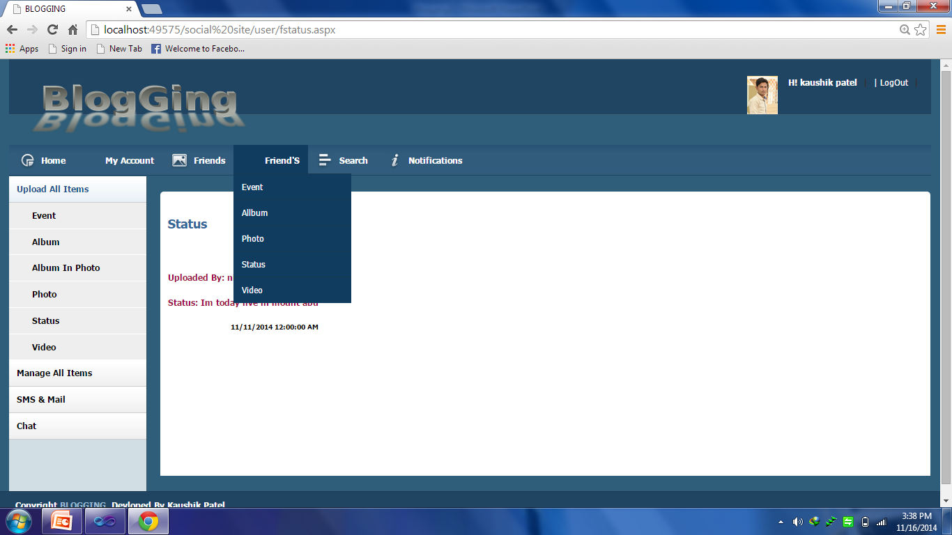

In this page user can view the friend status.

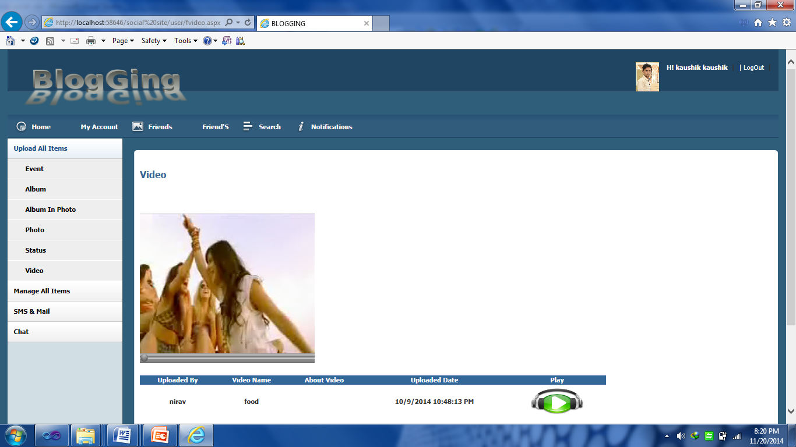User View Video Page

In this page user can view the friend Video.

User Search Friend And Send Request

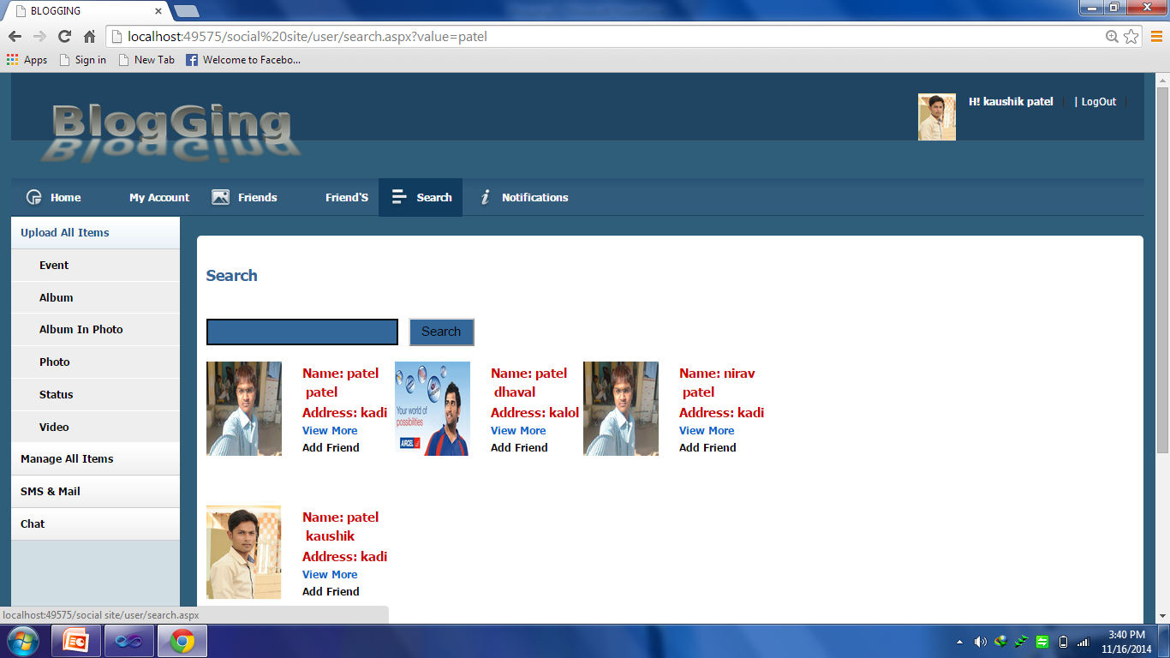

In this page user can search the friend and send the request to the particular user.

User View Friend Detail Page

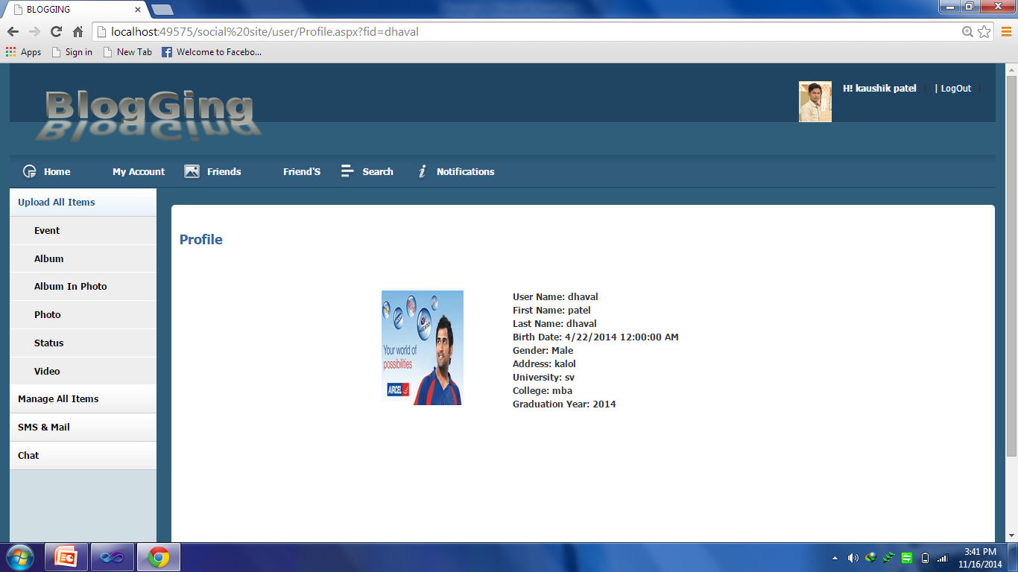

In the page user can view the friends profile detail.

User View Notification Page

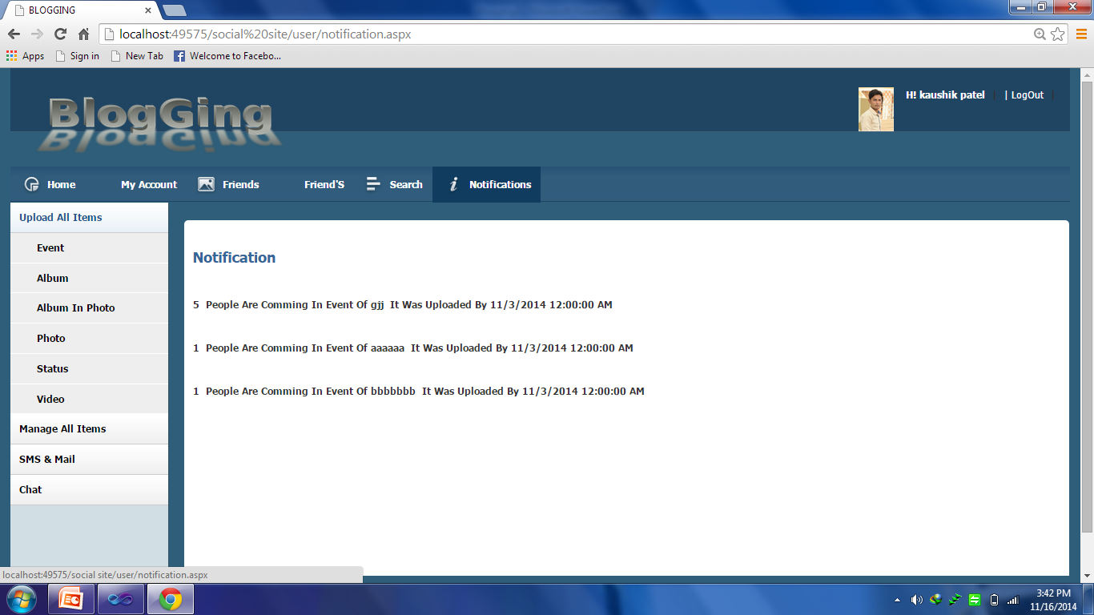

In this page user can view the notification of other user.

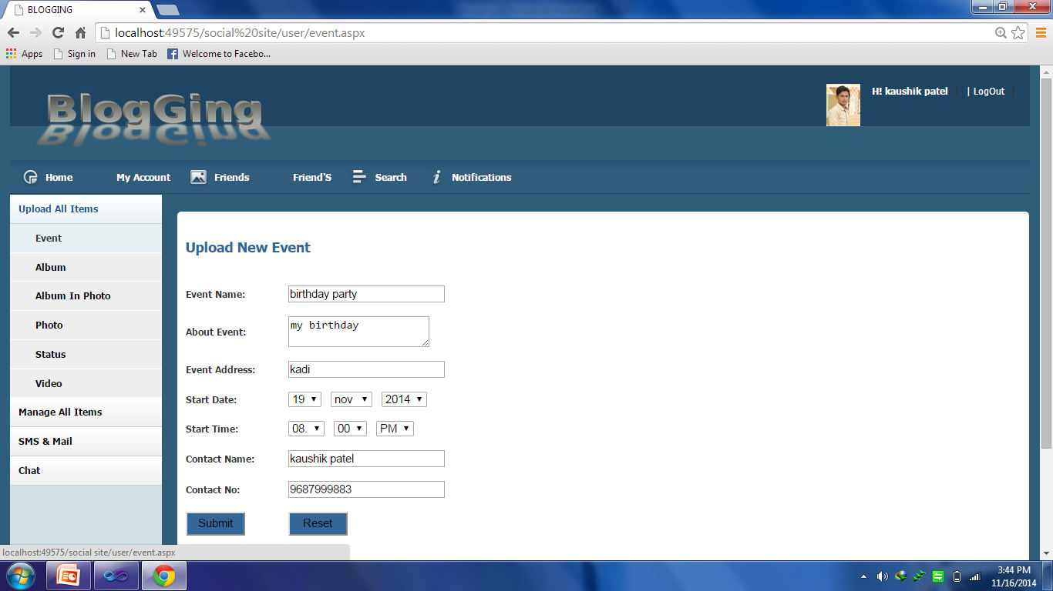User Upload Event Page

In this page user can upload the own Event and writing about the Event.

User Create Album Page

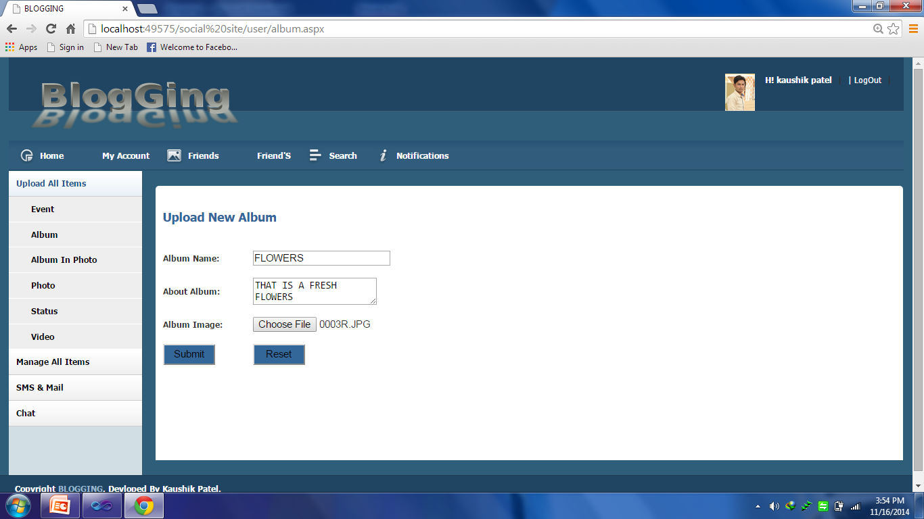

In this page user can upload the own Album and Upload photo in this album .

User Upload Photo in Album Page

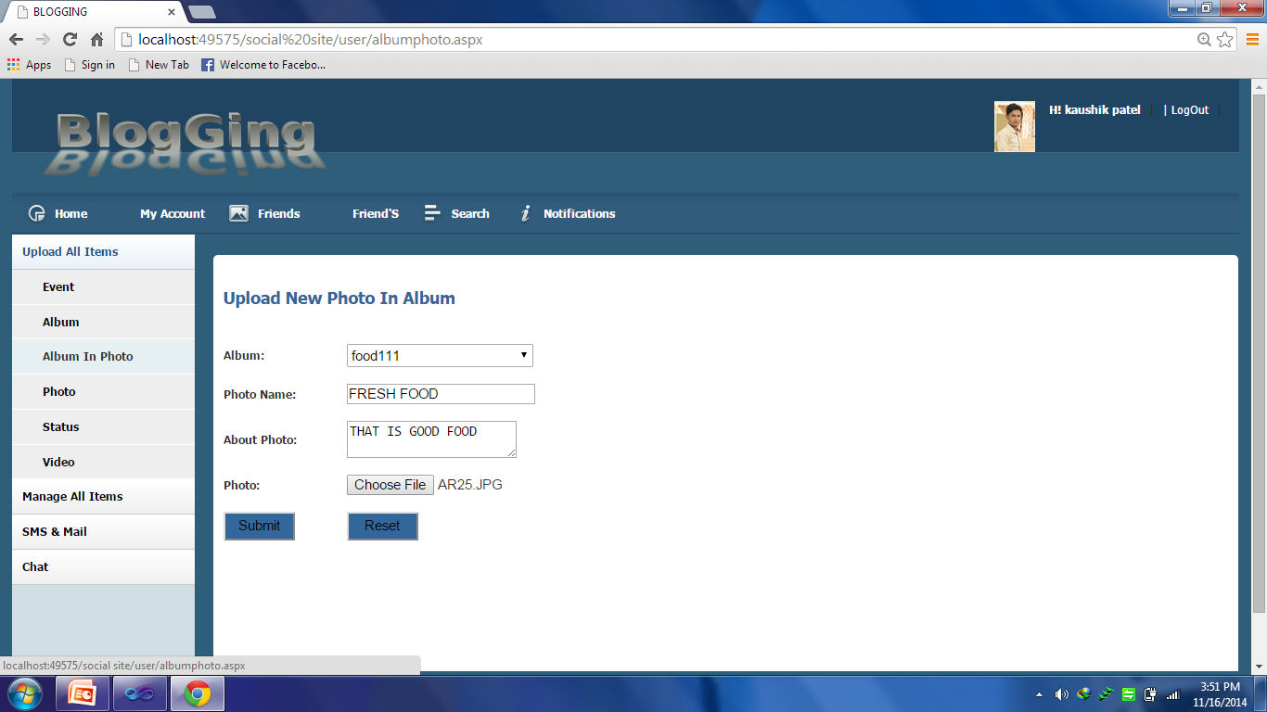

In this page user can upload the single or multiple photo in the album.

User Upload Photo Page

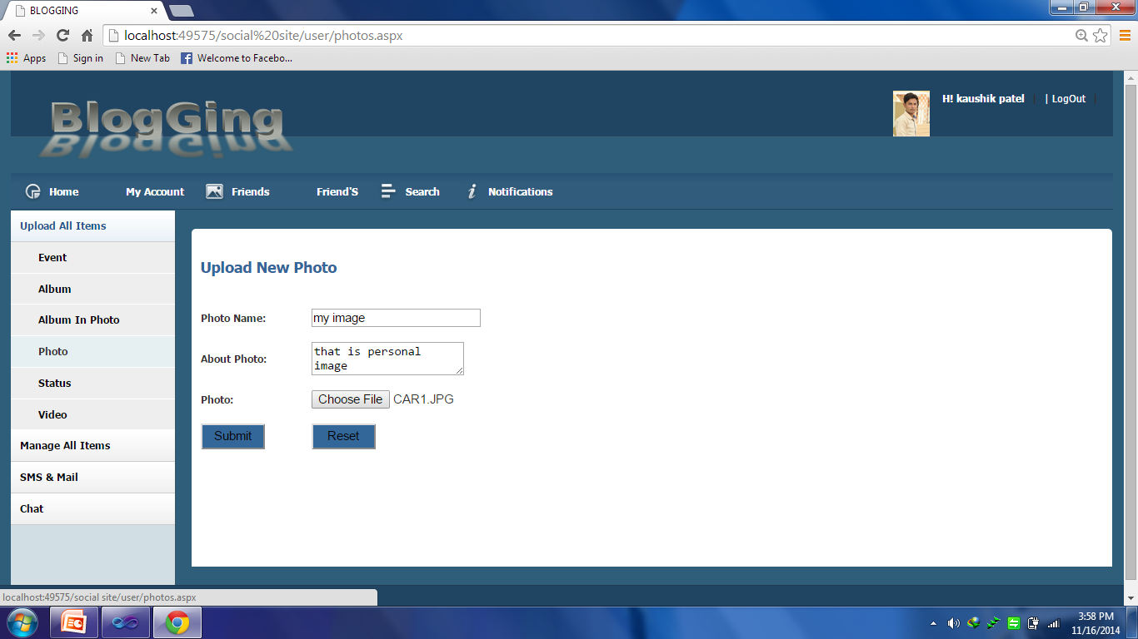

In this page user upload the new photo.

User Upload Status Page

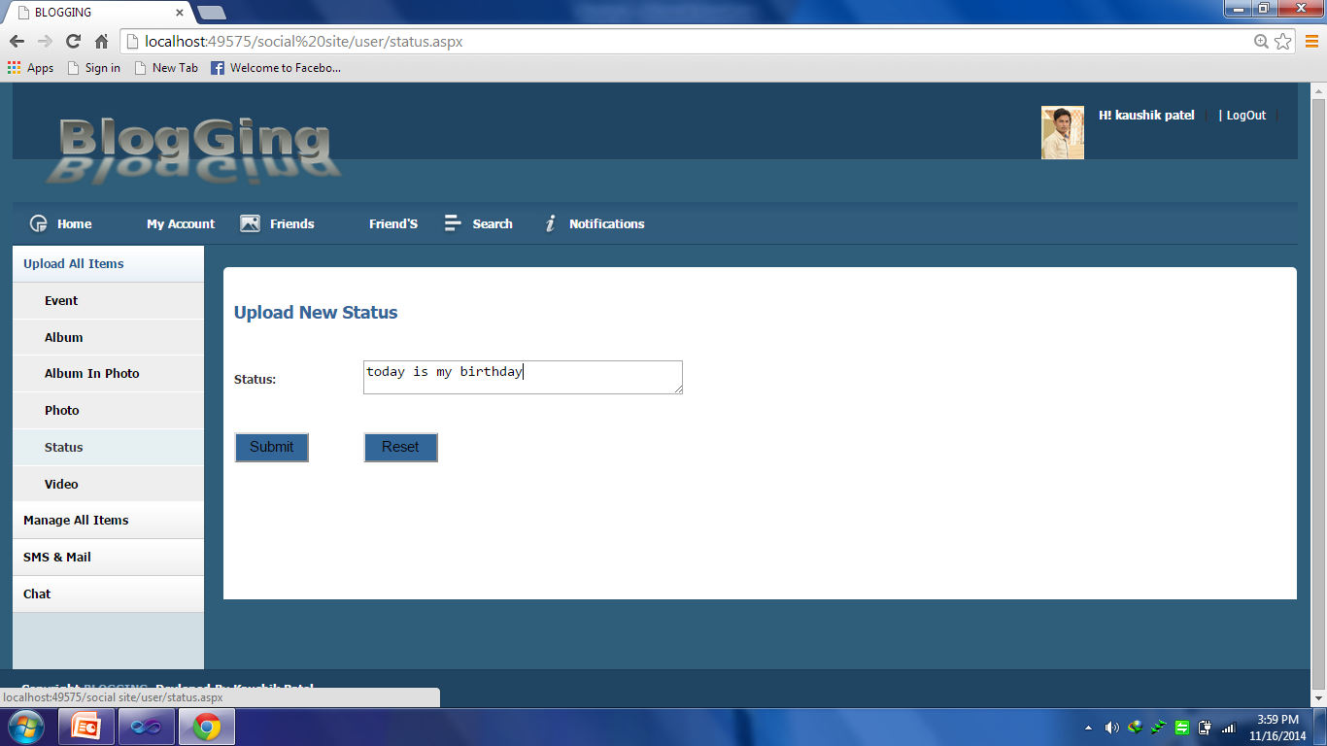

In this user can upload the status.

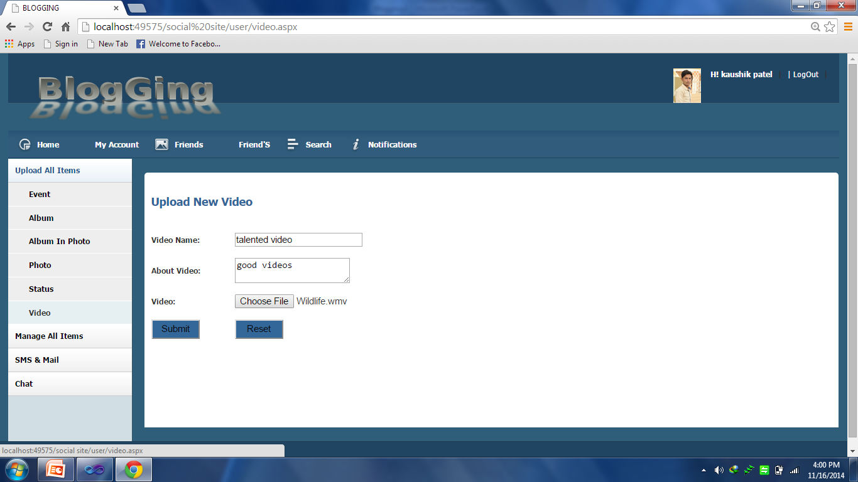User Upload Video Page

In this user can upload the Video.

User Manage Event Page

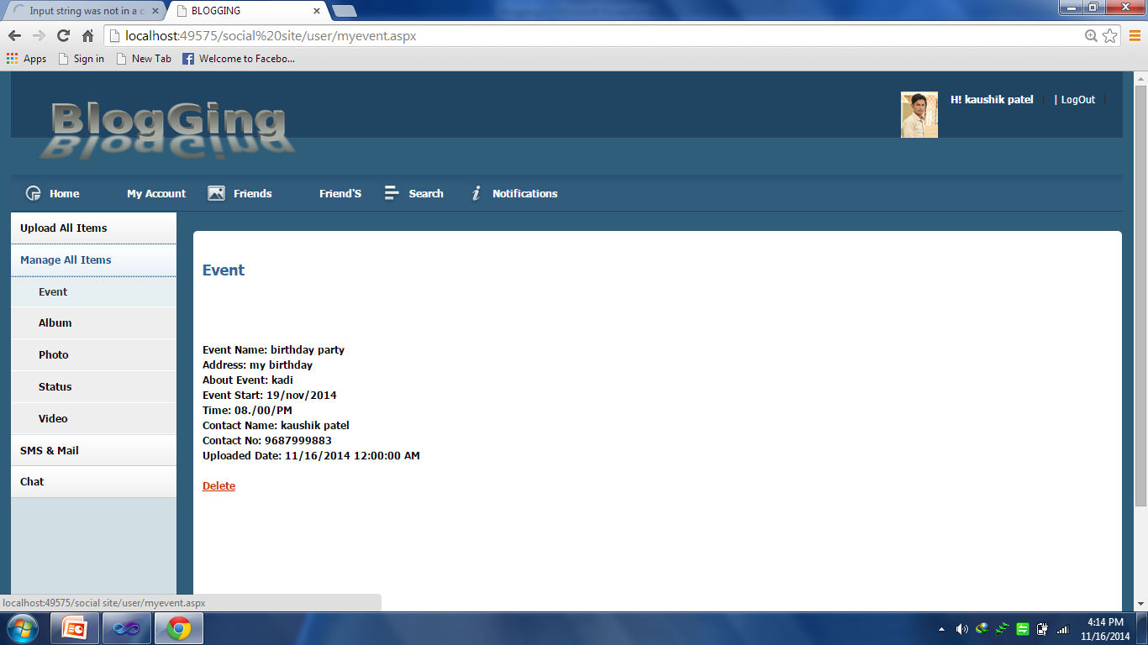

In this page user can mange the event like view or delete.

User Manage Album Page

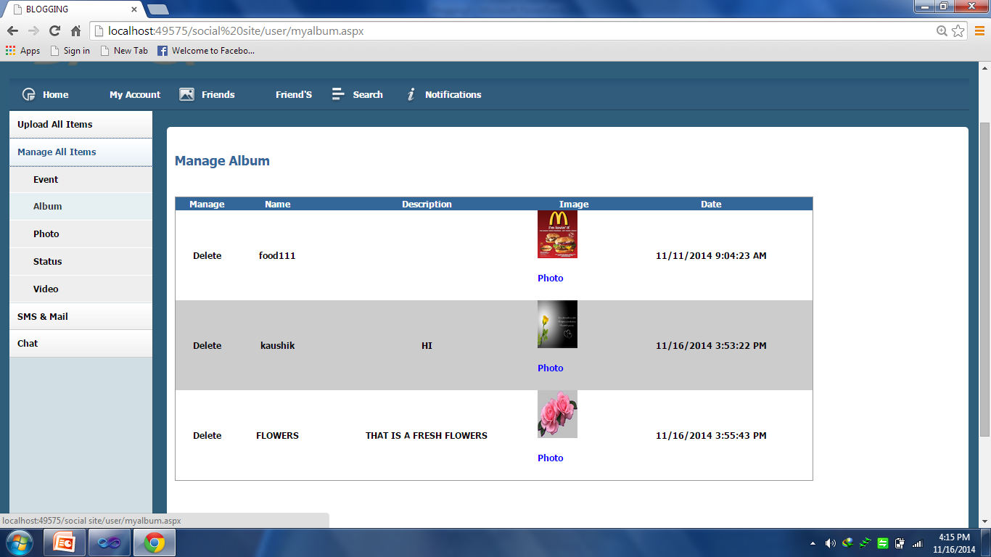

In this page user can manage the album like view or delete the photo album.

User Manage Photo In Album Page

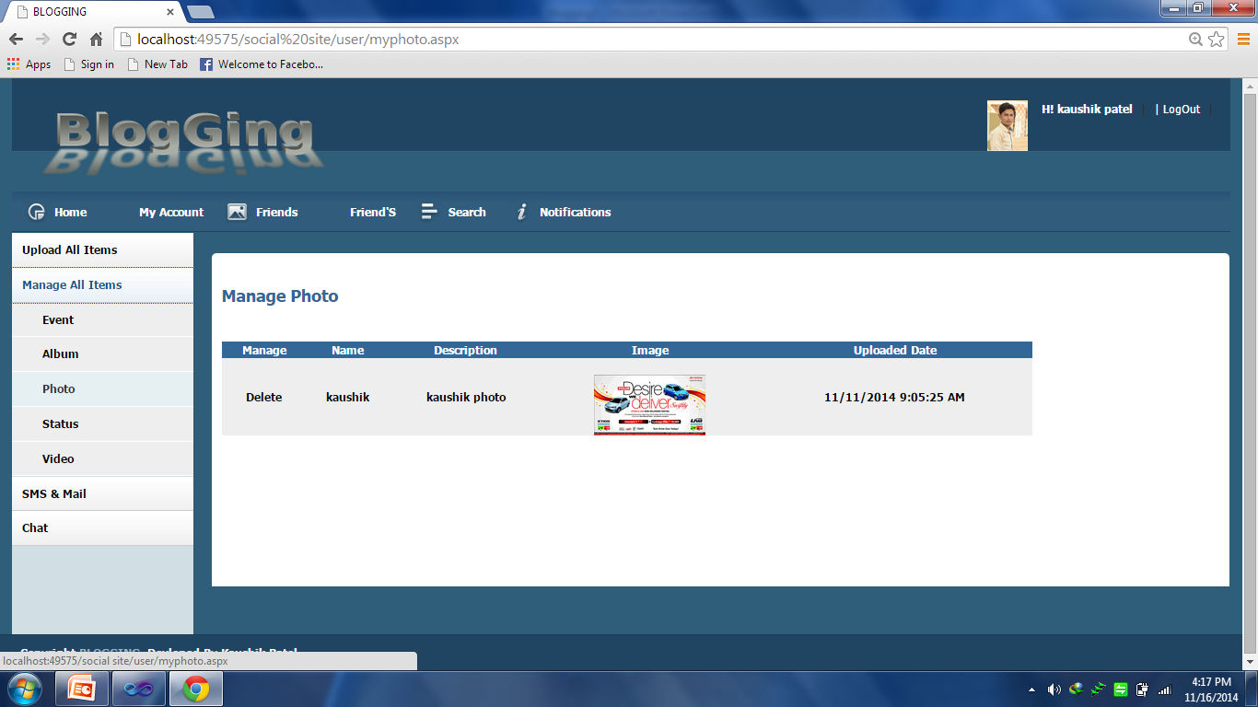

In this page user can manage the photo like view or delete the photo.

User Manage Status Page

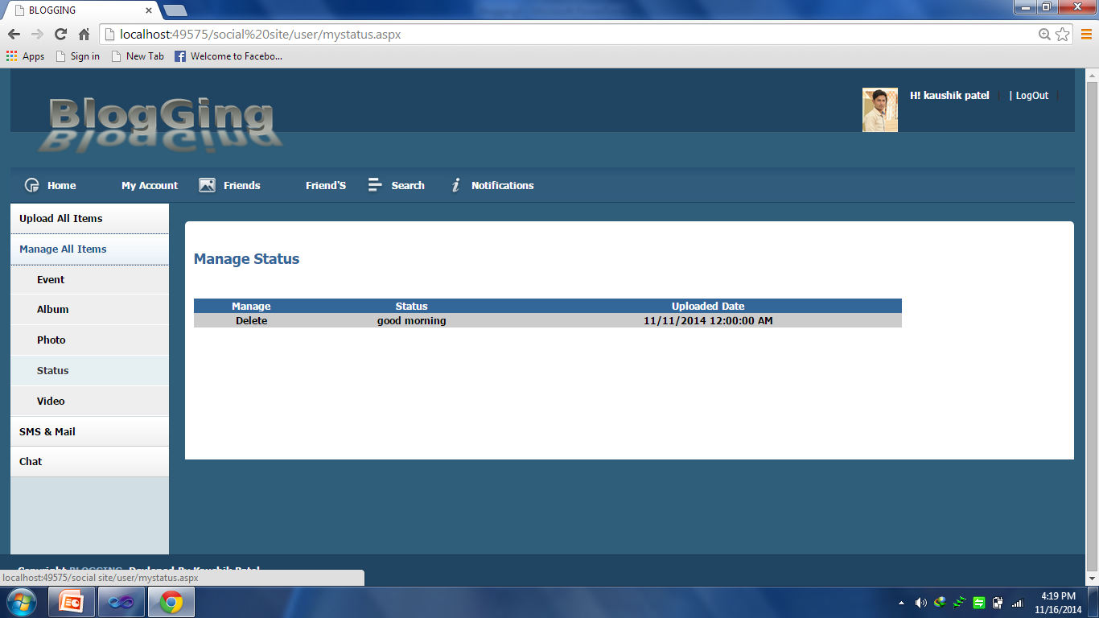

In this page user can mange the status like view or delete.

User Manage Video Page

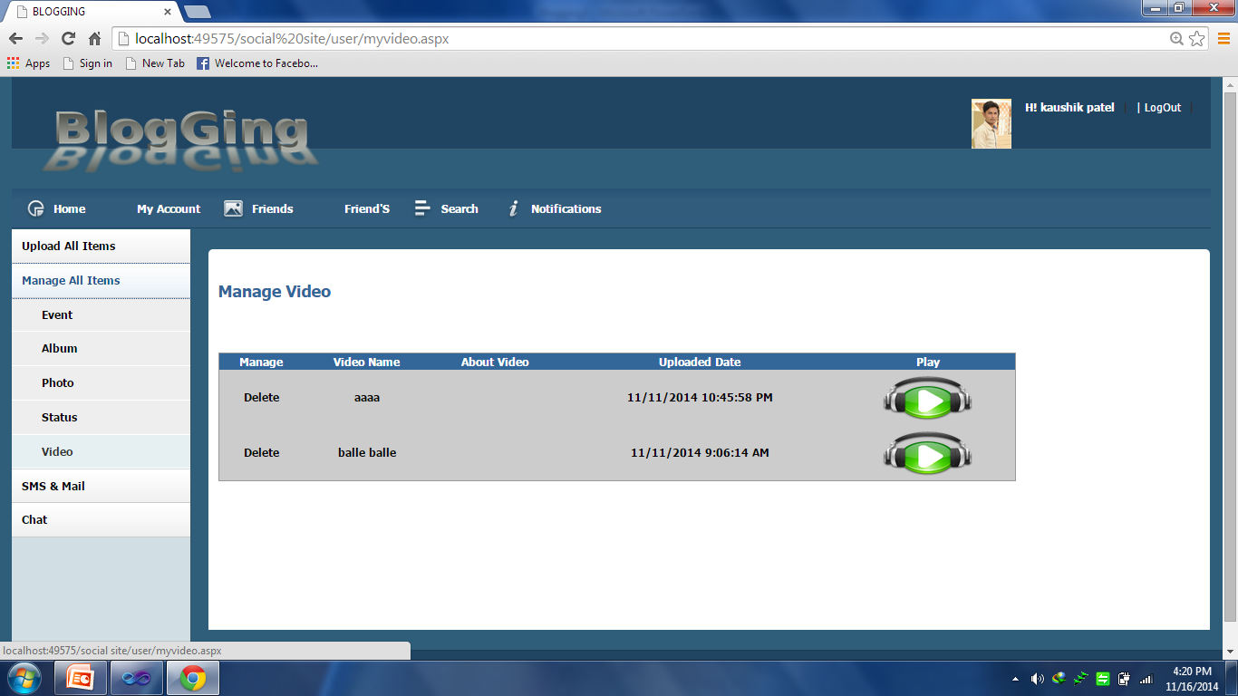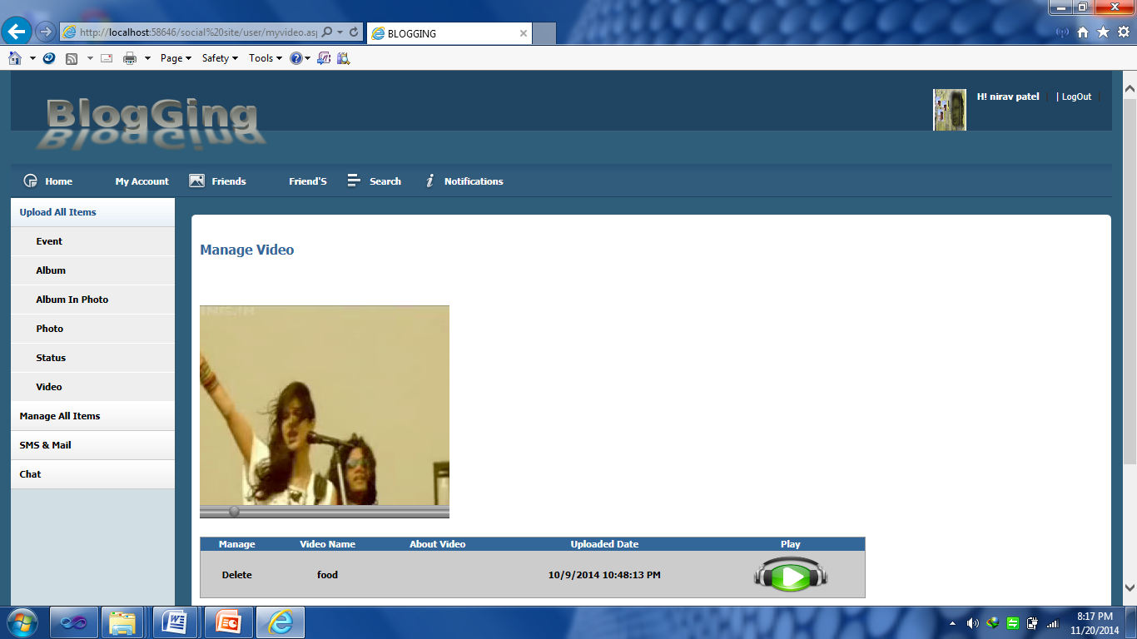

In this page user can manage the video like view or delete the old video.

User Send SMS Page

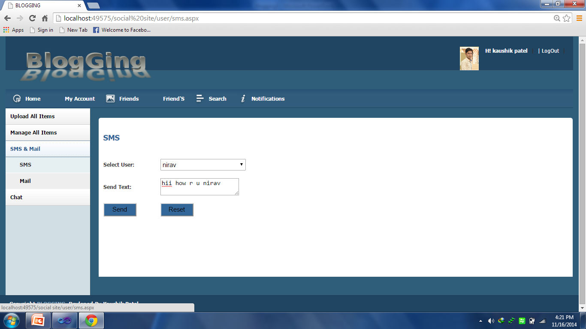

In this page user can send the send the SMS on mobile threw the ojaking gateway software.

User Send Mail Page

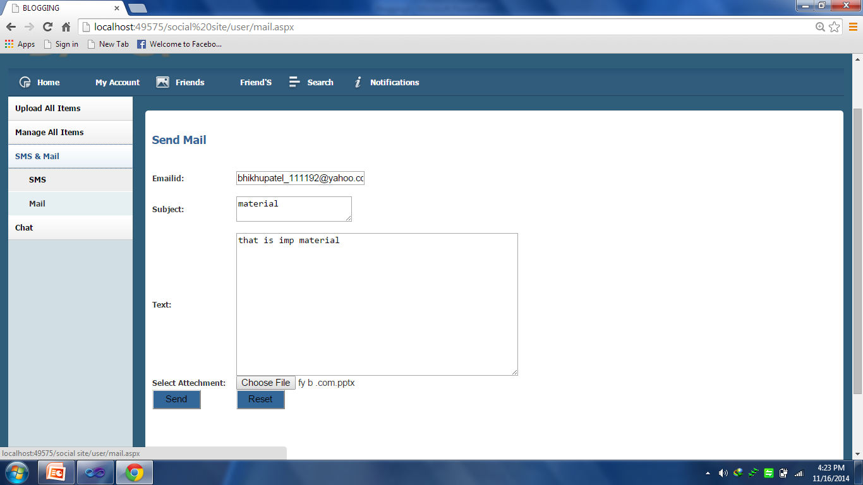

In this page user can send the mail.

User Chatting Page

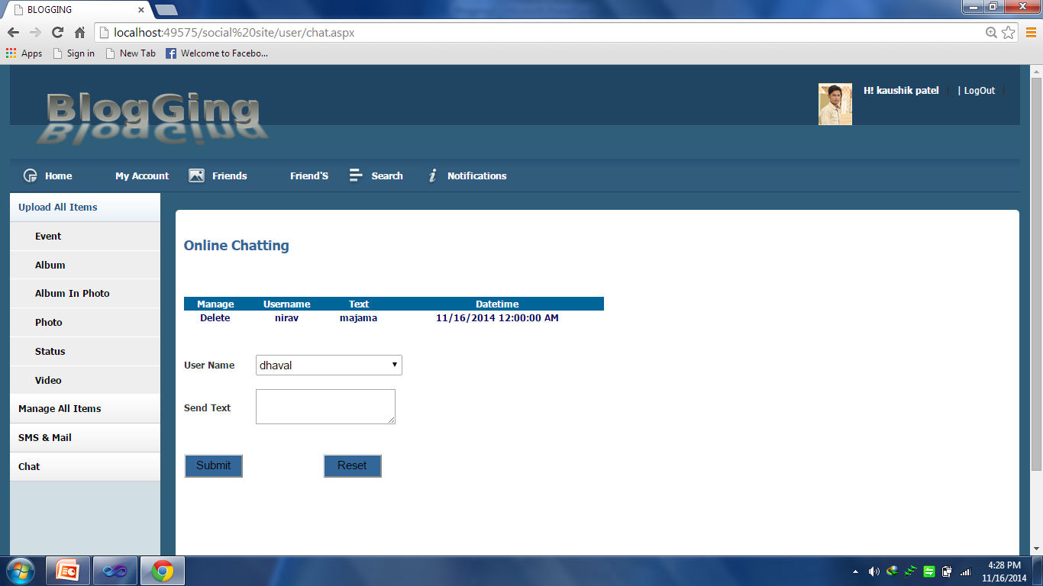

In this page user can send the mail.

User Logout Page

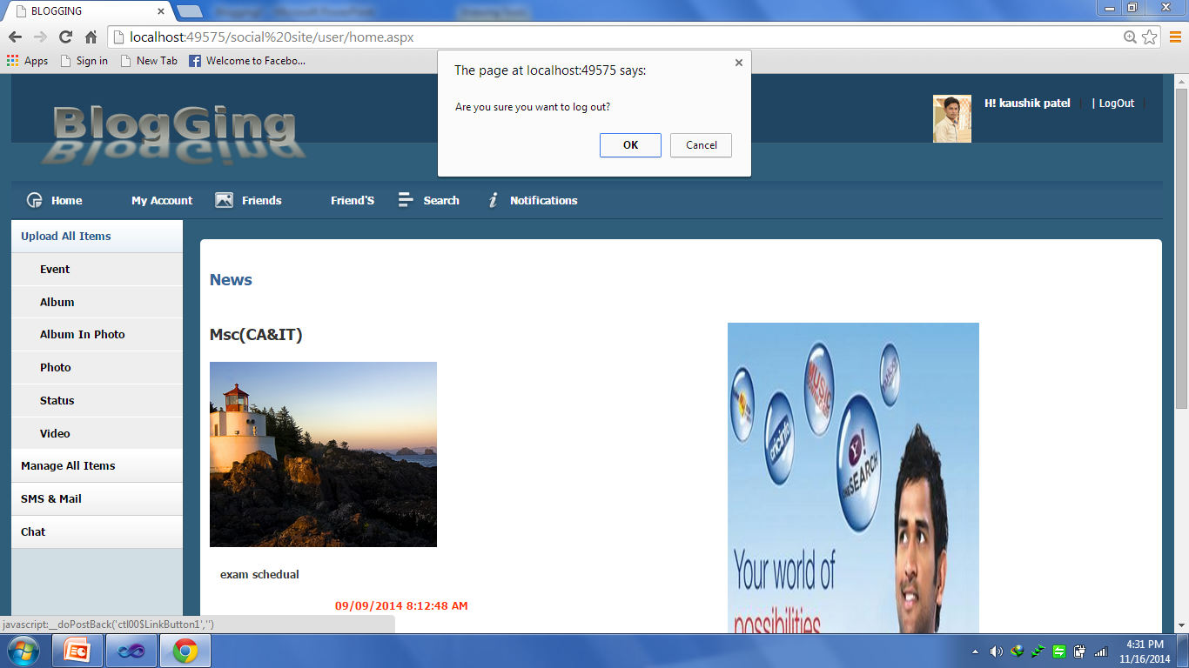

In this page user can logout from the system and after click on logout button confirm for logut.

# Output

### User Report

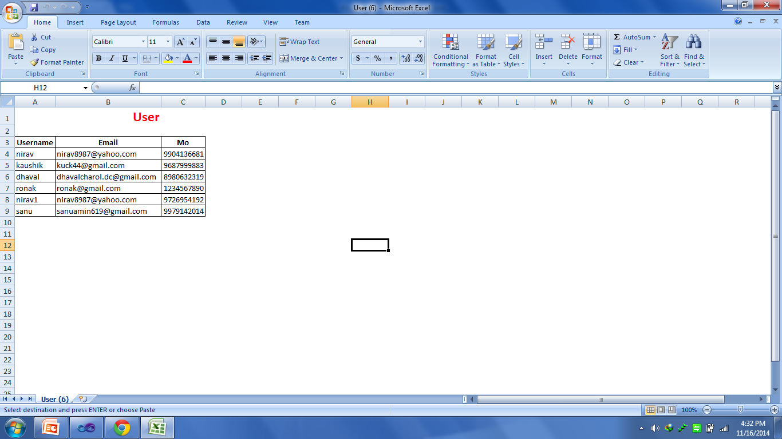

This report displays the user details in excel sheet.



Unit Testing :-

|  |  |  |  |  |  |
| --- | --- | --- | --- | --- | --- |
| **Sr No.** | **Test Case** | **Data Input** | **Expected Output** | **Actual Output** | **Pass/Fail** |
| 1 | Registration module | Enter proper data in the fields | If exist then give the message otherwise successfully register. | If exist then give the message otherwise successfully register. | Pass |
| 2 | Login module | Enter username and password | Get authenticated. | Get authenticated. | Pass |
| 3 | Forget password  module | Enter email id in the fields | If valid email id then send mail otherwise give  message. | If valid email id then send mail otherwise  give message. | Pass |
| 4 | Modify Profile module | Enter proper data in the fields | If data is proper then update profile otherwise give message. | If data is proper then update profile otherwise give  message. | Pass |
| 5 | Announcement and News module | Enter proper data in the fields | If exist then give the message otherwise successfully register. | If exist then give the message otherwise successfully register. | Pass |
| 6 | Advertisement module | Enter proper data in the fields | If data is proper then successfully register and send sms to register users otherwise give the message  . | If data is proper then successfully register and send sms to register users otherwise give the  message . | Pass |

|  |  |  |  |  |  |
| --- | --- | --- | --- | --- | --- |
| **Sr No.** | **Test Case** | **Data Input** | **Expected Output** | **Actual Output** | **Pass/Fail** |
| 7 | Event module | Enter proper data in the fields | If exist then give the message otherwise successfully generated. | If exist then give the message otherwise successfully generated. | Pass |
| 8 | Find Friend module | Enter proper data in the fields | If exist then give message otherwise successfully send  request | If exist then give message otherwise successfully send  request | Pass |

Validation Testing :-

|  |  |  |  |
| --- | --- | --- | --- |
| Test Case | Expected | Actual | Pass/Fail |
| E-mail | E-mail format must be Input | E-mail format must be Input | Pass |
| Confirmation Password | Password & Confirm Password Match | Password & Confirm Password Match | Pass |
| Text Field | All information must be input | All information must be input | Pass |
| Mobile No. | Must be a digit | Must be a digit | Pass |

[2] Validation Testing :-

|  |  |  |  |
| --- | --- | --- | --- |
| Test Case | Expected | Actual | Pass/Fail |
| Set profile | Set profile as per user requirement. | Profile will be set as per user requirement | Pass |
| Find Friend | Find friend using search option | Using searching option friend fined | Pass |
| Album | Upload Photos & Videos | User can upload his own Photos & Videos | Pass |
| Events | Create events | User can create his own Events | Pass |

|  |  |  |  |
| --- | --- | --- | --- |
| Test Case | Expected | Actual | Pass/Fail |
| Send SMS | Send SMS to Friends | User can send SMS to other friends | Pass |
| Send Mail | Send Mail to Friends | User can send mail to other friends | Pass |
| Advertisement | Admin can create advertisement | Admin can create advertisement | Pass |



* This system is much more user friendly an provide user interface.
* The system can easily followed by the users
* send SMS on the user mobile when user can have the friend request.
* Second one is that the user can create his own business pages on the site so user can advertise his own business at world level.
* Client also advice for the payment mode so any organization pay advertisement payment in online way.



The Social Networking Site have wide range to change as per time requirement. That the reason behind that not a particular project is ever considered as complete, because what the demand of user and thinking always change day by day. Always do more than what have.

Some of the enhance which we have thought of are :

* User can create his own business Pages for advertisement.
* Payment of the advertisement in online mode.

Bibliography:-

The following website and books was referred during the preparation of this project.

**Books Reference:**

1. Asp.net 2.0 Black Book (Author: - Rudraksh Batra)
2. Database System (Author: - C. J.Date)
3. System Analysis and Design (Author: - James A. Senn)

**Websites Reference:**

* [www.w3schools.com/html/default.asp](http://www.w3schools.com/html/default.asp)
* [www.w3schools.com/js/default.asp](http://www.w3schools.com/js/default.asp)
* [www.w3schools.com/jquery/default.asp](http://www.w3schools.com/jquery/default.asp)
* <http://www.dotnetfunda.com/articles/show/1084/saving-images-into-the-database-in-aspnet-and-> displaying-to-the-gridvi
* <http://www.ezzylearning.com/tutorial.aspx?tid=2693355>

